|  |  |
| --- | --- |
| Implementation of an Information System in Business - Video & Lesson  Transcript | Study.comBUSINESS INFORMATION SYSTEMS 1 | Politecnico di Milano  Luca Gerin |

Sommario

1. Information Processing Perspective 2

Theoretical underpinnings of BISs 2

Decision theory 3

Transaction economics 4

Agency theory 6

2. Operational Portfolio in Manufacturing Companies 7

Administrative portfolio 8

Manufacturing production processes and inter-functional information processes 8

Standard and custom production 10

Classes of information in the operational Data Base 10

IT integration 11

Computer Integrate Manufacturing – CIM 12

Materials Requirements Planning – MRP 12

3. Operational Portfolio in Service Companies 14

Service production processes and inter-functional information processes 14

Vertical and horizontal integration of the operational portfolio 15

Business process reengineering 16

4. Executive Information Systems 17

Functionalities of executive information systems 17

Technology architecture of executive information systems 20

Design steps of executive information systems 21

CSF method 22

5. ERP Architecture 23

The ERP paradigm 24

6. CRM 27

Analytical CRM 27

Executive CRM 28

Operational CRM 28

Call centers 29

7. Business Intelligence 31

8. Project management in BI projects 33

Business Intelligence projects structure 33

Business Intelligence projects approach methodologies 36

9. Business intelligence with SAP 38

ERP and Data warehouse 38

SAP - Systems Applications and Products in Data Processing 39

Data extraction and integration 42

User securities 43

Back-end vs Front-end 43

Data visualization 43

Predictive analytics 44

# 1. Information Processing Perspective

## Theoretical underpinnings of BISs

A **technology** represents a process (or a set of processes) that a given organization can perform, together with all the resources needed to perform the process. It is something an organization can do different from other organizations, the capacity to be able to do something.

For example, Pfizer has the technology to make its vaccine, Politecnico has the technology to produce engineers.

A **technical system** represents a set of machines supporting a given technology.

An **information system** is a set of coordinated processes producing an information output and executing information processing activities.

An **IT architecture** (or information technology) is a technical system supporting a given information system, so is the technical system for the technology of information system.

The organizational impact of technical systems is something subject to continuous study, innovation and improvement.

The traditional debate starts from a set of consolidated beliefs (not necessarily true!) tying technical innovation with organizational change:

* Technical innovation increases organizational efficiency (not effectiveness).
  + Efficiency: decrease input and increase output
  + Effectiveness: actual output / objective output; it does not depends on the input, it is the ability, the extent to which you reach the objective output
* Technical innovation enables scale economies
* Technical innovation causes an increase in the optimal minimum organizational size; in reality, for some companies it is more competitive to remain “small”
* Technical innovation increases individual specialization
* Tayloristic assumption: there exists an organizational optimum, optimal process obtained through optimal synchronization of individual tasks
  + Taylorism is by Taylor: engineer, production man, near the production processes, didn't know so much about the market
  + synchronize activities along the production chain, do it in the best way for the production, with the best distribution of resources and time
* Groupwork was not an issue (not studied)
* Technical innovation increases bureaucracy and formalization of work
* Overall, technical innovation increases the complexity of managerial tasks

Information technology changed this mindset.

Information is indeed a resource, but different from the others: I can use information to produce other things without losing it.

IT processes information, and information is the resource of managerial processes. So IT has an impact on the effectiveness of organization (not only efficiency). IT accelerates processes that are virtuous and makes them even more virtuous. If we apply IT to a no-well managed company, occurs the opposite.

If there is a change that is going to happen caused by external factors, companies should embrace this change in order to remain competitive.

There are 3 main schools under the information perspective, all of them talk about organizational change without referring to a specific technology:

* Decision theory
* Transaction cost economics
* Agency theory

## Decision theory

During the industrial revolution, at the time of Taylor, there was this assumption: as long as I can produce at a lower cost, the demand is there (no market perspective). So at the time there was not the problem of selling, there were surely costumers as the price dropped.

According to decision theory organizations are open systems, this means that they have to account with the market and the outside world, which has an influence on their success or failure. There is a constant exchange of information between the company and the outside world, which consists in the market system. So we cannot focus only on internal production and ignore market factors.

**Uncertainty** is the variable describing the unpredictability of the environment in which organizations operate. Uncertainty measures the ability of an organization to predict market demand. The determinants of environmental uncertainty are: risk associated with the business, number and diversity (heterogeneity) of suppliers, number and diversity (heterogeneity) of customers.

The organizations don't know what will happen in the market, so companies will have to make the right choices, or the money they invested could be gone.

In order to make a good prediction, therefore a good investment, good information is needed.

Information => effectiveness

Individuals have **bounded rationality**, a limited ability to process information. Bounded rationality is the cause for the creation of organizations, which can overcome the limits of individual bounded rationality if they create an information system.

This bounded rationality causes a need for cooperation among individuals, who tend to become more specialized in their work and knowledge. As people become more specialized and cooperate more, information interdependencies between individuals must be coordinated. In fact, due to bounded rationality, no single individual can process all the information required by an organization.

This is where IT comes into scene: IT is a coordination (or organizational) technology.

IT has an impact to be found in its ability for coordination and organization.

Decision theory considers a Hierarchical coordination system: a **hierarchy** is a coordination system based on command and control (delegation of execution, no delegation of decision-making activities).

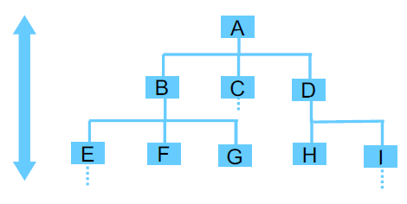Hierarchies are associated with:

* Vertical information systems and
* Horizontal (or lateral) information systems

with constraints given by information owning: before giving away information horizontally, you have to go up the hierarchy.

These two kinds of information systems allow organizations to increase their information processing capacity.

Information is sent by a unit in the hierarchy to its upper level when the lower unit does not have all information needed to make a decision on how to deal with the organization, or in case of exceptions caused by uncertainty.

The goal of information systems is the reduction of uncertainty.

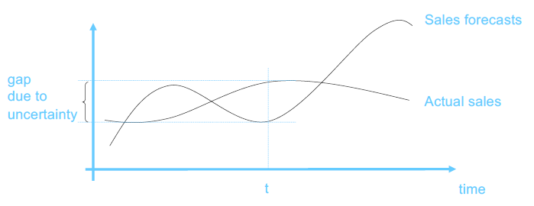Environmental uncertainty causes exceptions at the lower levels of the hierarchy, and to be handled there is a need to go up the hierarchy in search of information on how to handle them, in the planning and control levels. Here is where the limits of the **vertical information system** are evident. The vertical information flow towards higher hierarchical levels caused by exceptions cannot be handled by the bounded rationality of individuals when there are too many exceptions, so in situations of high uncertainty. So in the best scenario it takes too much time to handle exceptions and this causes a loss in competitiveness.

IT is oriented at reducing the lead time and the gap between the forecasts and the actual sales.

A solution, to implement when uncertainty is high, can be the implementation of a **Horizontal (lateral) information system**: it coordinates direct lateral information exchanges between units at the same hierarchical level. Such system is accompanied by a higher degree of delegation of decision-making activities. Who is up in the hierarchy doesn't know what happens down, just the output of their decisions they have been delegated to make. This is a cause of uncertainty. More delegation => more uncertainty.

There are 4 main forms, in order from less to more delegation:

* Liaison roles: organizational units devoted to problem solving in a specific area. They involve people from different organizational units and are cross functional.
* Task force: temporary team to solve a particular issue, composed of people from different functions.
* Teams: permanent groups of people, co-located in a place like an office, devoted to deal with an issue, a project, a change, a plan.
* Matrix structures: One employee has multiple bosses, one for every dimension of the matrix (geographical, functional, project, ...), and works on different projects depending of his pool of skills. On every dimension, hierarchy is still present. The individual has the task to make sure that the orders he receives from different bosses are consistent with each other, so he must be proactive (high delegation).

Horizontal information systems => organizational flexibility: ability of an organization to react to exceptions that occurs in the environment and very quickly respond with a solution.

In conclusion, companies deal with environmental uncertainty by increasing their information processing capacity by implementing vertical information systems and horizontal information systems.

As an alternative, they increase their **slack resources** by implementing:

* Slack resources (e.g. warehouse)
* Independent organizational units according to the divide et impera paradigm, for example with divisional organizational forms (divisions are separate units that replicate the functional unit)

The increase of the slack resources is an option that has a way higher cost and it is not always applicable: not for every situation there exists slack resources.

Decision school has Limitations:

* It considers hierarchies as the only coordination mechanism (both vertical and horizontal information systems are based on hierarchies) **->** market coordination is a coordination mechanism that can replace hierarchies when they become inefficient
* The concept of open system only considers one kind of uncertainty, the one given by the market. Decision school considers environmental uncertainty as the only form of uncertainty **->** behavioral uncertainty caused by the opportunistic behavior of individuals can impact on the effectiveness of hierarchies

## Transaction economics

Transaction costs economics aim at overcoming decision theory limits.

An **economic transaction** is an exchange between a customer and a supplier in which the customer receives a product/service from the supplier in exchange for a given amount of money. Individuals prefer transactions to being part of hierarchical organizations, as they feel more free: the individual chooses what to buy and becomes the owner, with a legal value.

Individuals and organizations cooperate with transactions. A transaction is executed when an individual/organizational objective is beyond the limits of individual/organizational rationality, for example if a good is too expensive to produce it can be bought.

The **Market system** is based on and supports the execution of transactions. It reduces behavioral uncertainty by leveraging opportunism.

In market systems, individuals produce for themselves and have maximum benefits from their own efficiency.

However, coordination involves the execution of a transaction, that comes with a **transaction cost**. Transaction costs are minimum only in transactions are executed in so-called perfect market conditions, but this is only a theoretical concept.

The overall cost of a coordination mechanism is the sum of production cost and transaction cost.

Cost of coordination = production cost + transaction cost

In market systems production costs are low, as individual tend to be very efficient, while transaction costs are low only in perfect market conditions.

A company can opt for a make solution whenever the market is too far from perfect market conditions and price increase too much and is no longer a good indicator of actual quality.

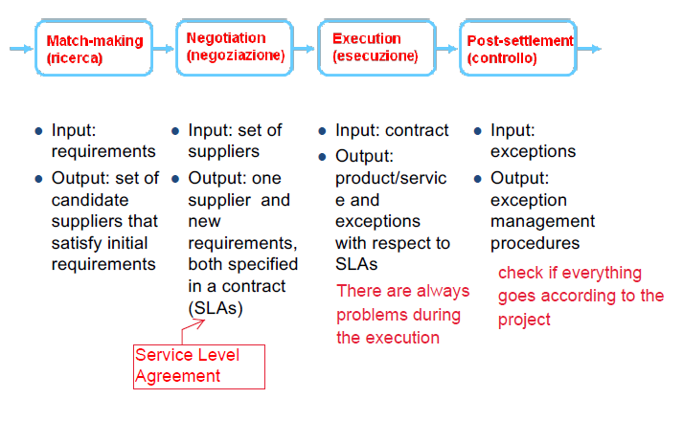There are 4 main phases of an economic transaction:

* Match-making
* Negotiation
* Execution
* Post-settlement

Typically, the choice of a good (+ service) is based on the price.

The market is coordinated by a mechanism based on the price system. So the **price system** is the information system of the market coordination mechanism.

However, prices are not a set by production costs only, but also by the market system (trends, common ideas, …).

Market systems are based on trust:

* the parties in market transactions have an unconscious trust in the ability of a market system to lead to a good quality-as-price made though the competition mechanisms
* the parties in market transactions have no control on each other’s production processes
* it is difficult for a buyer to assess the actual quality of products

If the market system works properly, price is not too far from production costs and is a good indicator of quality, but this is not always the case.

There are some causes for the failure of market systems:

1. Shortage of good/service: low supply and high demand causes the prices to rise
2. Complexity of good/service
3. Specificity or need for personalization of good/service: causes the price to rise
4. Environmental uncertainty and information asymmetry
5. Negotiation power of customer/supplier: the buyer is always in a weak position
6. Frequency of transaction

So, to deal with the conditions of the market, it is possible to make a choice between market and hierarchical coordination mechanism, this **make or buy** choices are driven by cost. Make or buy decisions are made based on cost trade-off: the opt for a make solution whenever the market is too far from perfect market conditions and price increase too much and is no longer a good indicator of actual quality. Also, these decisions are based on the ability to be competitive and grow in size to accommodate the company’s “make” needs.

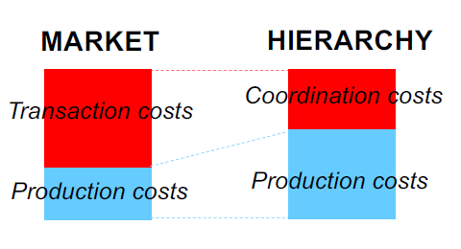The cost is divided in 2 components:

* Transaction cost/coordination cost: in hierarchies there is coordination cost due to exception handling, in market there is transaction cost due to the market conditions and on how efficient the market coordination mechanism is in the execution of transactions.
* Production cost: the cost of production; production activities are more efficient in a market system because people execute production activities for themselves.

IT is an organizational technology that reduces coordination costs.

IT has a greater impact on market systems, as in market systems there are bigger costs associated with transaction (market coordination), so should reduce hierarchies (smaller and more numerous companies).

IT is also a production technology, so can contribute to reducing production cost.

Also transaction cost economics have their limitations:

* They consider markets and hierarchies as alternative coordination mechanisms, while they should be used together.
* They ignore the impact of behavioral uncertainty inside organizations.

## Agency theory

Agency theory aims at overcoming transaction cost economics’ limitations.

It starts from a consideration: there exists a continuum between markets and hierarchies: in particular, there exist market coordination mechanisms inside organizations. So, organizations can apply market coordination mechanisms to increase their efficiency.

Organizations are seen as networks of contracts among individuals. At first an employment contract, then every production process is based on a model involving a contract between different units cooperating in the execution of the process. Every transaction is a contract.

Coordination inside organizations can be based not only on command and control, but also on the execution of transactions.

The transaction costs inside organizations are called here **agency costs**, these costs emerge every time a decision-making task is delegated towards lower levels of the hierarchy.

Delegation represents a task with which a responsibility higher in the hierarchy enables another responsibility lower in the hierarchy to make decisions on a set of interrelated activities. Delegation is an organizational must to make vertical information systems more efficient when environmental uncertainty is too high.

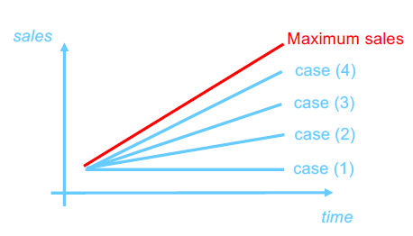An example of agency costs are the costs correlated to delegation, which vary according to the kind of contract with the employee:

1. Fixed salary
2. Fixed salary + percentage on sales
3. Fixed salary + large bonus upon fulfilment of sales objectives (sales threshold)
4. Fixed salary + all gains from sales – structure costs

Contracts are decided in a way to improve market competitiveness working on the hierarchy.

The company needs to be highly mature to go from option 1 to 4. In fact, from solution 1 to solution 4, the degree of delegation increases, so the employee acts as an entrepreneur inside the organization.

Of course, soft managerial levers can be used to make sure that internal entrepreneurs do not go against organizational objectives (Rules and constraints, organizational culture, Image, Shared branding actions, …).

Delegation is accompanied by internal contracts similar to market contracts and, thus, creates an internal market with additional coordination costs, that are the agency costs.

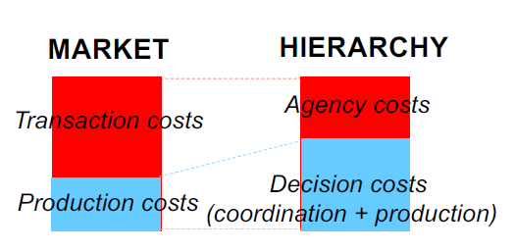They are costs that organizations have to take on to either control or provide monetary incentives to employees to whom they delegate decision making activities, and costs that are due to behavioral uncertainty. So agency costs are also costs with the aim of making sure the employee pursues the company’s objectives. We can also say that agency costs are due to behavioral uncertainty.

So now, with agency theory we have production costs and coordination costs (composing decision costs), but also the new type of cost which is agency cost.

Agency costs = control costs + warranty costs + residual loss (opportunity costs)

Inside market systems there is a hierarchical control.

In perfect market systems, customers have no control over their suppliers. Pure markets work well when trust is high and delegation is total. On the other hand, in non-perfect markets, customers can control their suppliers to some extent. They have visibility over their production process and, in some cases, apply to their suppliers hierarchical forms of control.

Agency theory has its limitations:

* There exist hierarchical coordination mechanisms inside market transactions
* The agency school neglects the uncertainty caused by the nature of the task to be executed
* The role of technology is strongly tied to the nature of tasks
* Technical innovation represents a driver of organizational change that, depending on the nature of tasks, can change the cost balance among different coordination mechanism

Information system theory aims at overcoming these limitations

# 2. Operational Portfolio in Manufacturing Companies

In manufacturing, companies produce tangible products. On the opposite, service companies produce intangible products. So for service companies IT is also part of the production phase.

Big companies realized that many tasks in the majority of companies are very similar, so the same software for those processes can be deployed by different companies. The trend has been to buy this software, suitable for more companies, instead of making it. This software is called **ERP** - **Enterprise Resource Planning**.

Typically, ERP systems have vertical solutions tailored to the needs of specific industries.

ERP providers standardize as much as possible the software in order to be more competitive, but it is not possible to produce a software that can work for any type of company.

An effect of the ERP is that they standardize operations within the same industry and so have the same managerial patterns.

Cost and competitiveness trade-off: the more you standardize, the less you spend, but you become less unique and so less competitive.

Information technology and software in particular is an asset for companies: it has economic value and it is made by several applications and functionalities that increase competitiveness.

We can make a distinction between three areas of application of information technologies: administrative, operational, executive.

So the IT portfolio of a manufacturing company is composed of:

* Administrative portfolio
* Operational portfolio
* Executive portfolio

These three functional areas have developed separately and are now integrated inside ERP systems. They constitute the *core functionalities* of ERP systems, they represent the basis that a company should have in order to start innovating.

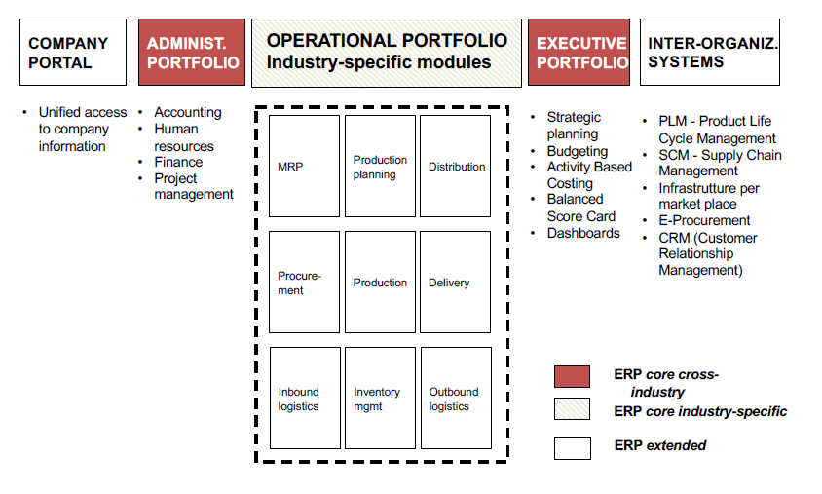

## Administrative portfolio

It automates administrative and bureaucratic organizational activities, including:

* Accounting and tax payments
* Finance
* Human resources
* Finance and investments
* Project management from an accounting perspective
* Governmental procedures (e.g. pensions, insurance, etc.)
* Sales and costs predictions

It is the first portfolio to be automated, as number crunching is very easy to be performed by computers.

It is almost industry independent, but it is country-specific due to different country’s laws about taxes or regulations for accounting or human resources.

It involves limited decision-making, while it is procedural and repetitive.

It is traditionally considered stand-alone, but it is not (activity based costing).

It can be functionally complex (e.g. the balance sheet). This can be a disadvantage because if regulations change, the software has to change. Companies have started experiencing the concept of obsolescence.

## Manufacturing production processes and inter-functional information processes

Companies are different, so they have different opportunities and applications of information technology. Some innovations may be more suitable for certain industries than for others.

Porter elaborates the concept of **information intensity**, which represents the size and complexity of the information used by the processes of an organization. It responds to the question: how many information is used in the production and management processes of one company and how complex is it?

**IT intensity** is the actual ability of IT to satisfy the information processing requirements of organizational processes. Like for information intensity, some industries have greater opportunity to take advantage of information and information technology than others.

We also need to take into account **management inclination**, the degree to which a company’s management considers IT as a strategic lever. It depends on a lot of factor including computer literacy of managers.

In general, information intensity in greater in services than it is in manufacturing, but can be the opposite.

Porter defines drivers of IT intensity:

* Degree to which information processing activities are structured and, thus, can be easily translated into a computing procedure. Information processing activities are more structured the more predetermined steps they follow.
* Volumes: the amount of information to be processed. The higher the volume, the greater the opportunity to apply IT.
* Frequency with which a given operation is repeated. If there is a repetition, with IT the computation has to be made just once.
* Computational complexity of operations, the simpler, the better.

So we want activities to be structured, to operate on great volumes with simple and repetitive operations.

For manufacturing production processes, Porter produces model, the **value chain.**

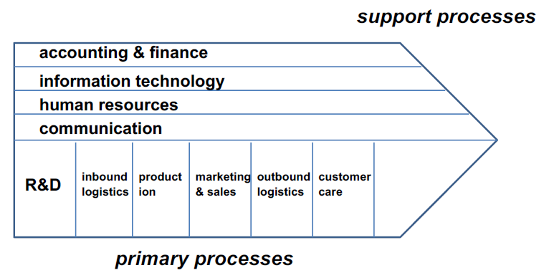

This model is important because it shifts the focus from functional hierarchy to the processes that a company has to accomplish. Manufacturing processes are not depicted as a function of hierarchy, that still exists. So we do not focus on the skills of people, but on inputs and outputs of processes.

There is a distinction between two types of processes:

* **Primary processes**: the steps to go through to produce the outputs as final products and services. They are transformation processes.
* **Support processes**: not directly involved in the transformation of input into output, but they are needed by the primary processes. They typically are common to all primary functions (this is why they are depicted orthogonal to the primary processes.

The chain value has a limitation: the boxes of the processes look like functions.

So Porter proceeds to map the cyclical activities that companies make onto the chain. These manufacturing activity cycles are iterative and continuous, and can be distinguished in two kinds:

* **Development cycle**: It is in charge of designing and industrializing new products and production processes. Companies are continuously designing and industrializing new products and production processes.
* **Logistic cycle**: it is in charge of managing customers’ orders, with the following activities:
  + Procurement
    - acquisition of materials
    - physical management of materials: internal logistic processes, such as reception, warehousing, dispatching to productions plants, etc.
  + Production: physical transformation of materials
  + Sales and distribution:
    - order management,
    - external logistic processes,
    - post-sale processes (maintenance, customer support, etc.)
* Maintenance and Customer support

There is information flowing through and needed by those processes.

Porter calls these inter-functional information processes in order to stress the idea that information is by nature created and used along a process and that process is inter-functional. So we have:

* *Order management process*: it manages the information regarding orders from order check in to post-sale services.
* *Materials management process*: it manages the information regarding materials from outgoing orders towards suppliers to usage within transformation processes.
* *Operations management process*: it manages the information regarding operations from materials dispatching to production plants to product delivery.

Every individual task that is performed inside an organization has to be identified and described in the Data Base. These three kinds of processes correspond to three large tables storing information about orders, materials and operations. These are actually inter-functional information processes. There is a flow of activities that occur overtime and there is a function that creates the information and other functions use it.

Different products and different divisions involve all production processes and all inter-functional information processes; therefore, the information system is tightly bound to the organizational structure.

Information can be produced in a function and possibly used in different other functions, so different production cycles share information, for example:

* Information on stocks is created by the materials management and used by order management during sale activities
* Information on stocks is created by the materials management and used by production
* Information on orders is created during sales activities and used by production
* Information on orders is created during sales activities and used by internal logistic

Information in typically created at operational level, at low hierarchical level, and then needs to collected, aggregated and provided to the higher managerial levels. Managers need this information for their continuous planning and control cycles. So, inter-functional information is used by the planning and control processes (or management processes), it is the resource used by planning and control: strategic production planning, budget allocation, scheduling and operations management.

It is also used by administrative activities: cash flow management, project management. These activities are important because from them come the constraints on production: limits in operational capacity and limits on money availability.

When an information is created by a function, it is rarely needed only by that function.

## Standard and custom production

ERPs support different types of production to a different extent and in different ways. The software that is used to support standard and custom production is quite different.

So we make the distinction:

* **Standard production**: products have a finite set of predetermined features that can be changed to accommodate customer preferences (e.g. color, size, optional, etc.). In this case, companies produce according to a sales plan, before actual orders are received.
* **Custom production**: products are designed according to customer requirements and then produced on demand (if something is produced a corresponding order must exist).

Usually, standard production is preferred because it allows to eliminate production times, as you produce in advance, and this increases competitiveness because the customer doesn’t have to wait and is not exposed to competition. With custom production, there is enough significant time between order and delivery of goods to the customer. Moreover, with standardization companies can maximize efficiency not only in terms of production but also in financial efficiency. If you do not standardize, you will remain small and compete on small features for a small subset of the potential market that interests standardized productions.

Intuitively, custom production is associated with complex artifacts, while standard production is associated with simple artifacts. Actually, the degree of standardization and the degree of complexity of products are independent variables and all combinations exist. Information technology (IT) applies to all combinations, but functionalities

are substantially different.

## Classes of information in the operational Data Base

Information in the operational DB is classified this way:

* **Transaction information**: describes the flow of operational activities in terms of exchanges between responsibilities (or organizational units along production processes) and between internal responsibilities and external players. As activities are performed, not only we describe the nature of the expected result of activities, but we also describe when that has occurred exactly and provide a bunch of additional information about the time when the transaction was operated. We keep time under control, and we keep responsibility under control. If there’s a delay, we know exactly who’s been responsible for that. Transaction information is what allows you to keep track of the time performance but not only that, of your production process. What you store is not only the static description of the objects that you deal with, but also the dynamic description of all of what happens in the company, which is transaction information and that is huge. Transaction information has a big complexity.  
  *Examples*: Contracts with customers and suppliers, Status of production activities, Transfers of materials and half-finished goods between responsibilities, Certification of events, such as inclusion of a new product in the catalog, the certification of a new supplier, etc.
* **Operations planning information**: it describes the objectives and the expected results of operational activities. For operation planning information, we should be able to describe for each operation that is identified the objectives and the expected results. It is the typical managerial information, and is smaller in size compared to the transaction information. It stores the production plan, so that everyone at operational level knows exactly what he has to do, produce, the product code, quantities. Operations planning is always associated with corresponding transactions. So, Planning information defines operational production plans, that is the goals of operational activities, the resources that should be used and the responsibilities that are in charge of execution.  
  *Examples*: a table containing in each row the product code, the quantity to produce, the machine to use and notes.
* **Catalog information**: it represents a basic knowledge that is independent of the flow of production activities. It is referred to as a static type of information (although it is not). In fact, it changes over time but with respect to the frequency of activities that are performed, we can consider it static. This kind of information is small in size but complex and needs continuous maintenance. It impacts on organizational learning capabilities and can limit the consequences of personnel turnover.  
  *Examples*: Product catalog, Customer directory, Supplier directory, Workforce directory, Product structure

A particular kind of catalog information is **product structure**: Hierarchical description of the structure of products, from elementary components to aggregate product parts.

Product can be represented as a hierarchical structure and divided into components which are divided in subcomponents, and so on. The division is based on the production process. This structure is an input for the question: which materials you need to purchase from the market to produce a certain amount of product that represents the objective?

Also, you need to know when to order from a supplier according to the supplier usual times. Then you need to know what machines to use and how to exploit them the best way, and what professional skills to employ. This all is part of catalog information.

Some observations on sizes and complexity: transaction information is the largest in terms of volumes, while catalog information is the most complex in terms of number of attributes (data schema). Operations planning information is a key link between the operational and the executive portfolios.

The level of detail of operational information is a driver of the efficiency of coordination inside an organization. Having enough level of detail is key support management planning and control activities. So, operational information is an organizational asset. In some cases, the operational information can be sold (always respecting the GDPR, General Data Protection Regulation). In fact, information of one company can be useful to the supplier of that company, the clients, the competitors and companies operating in the same field. Some companies collect their information in a way that makes easy for them to sell it. Some information may be strategical for a company and could not be sold even at a price.

## IT integration

When IT was initially used at operational level, the objective was only automation. CIM and MRP, with their set of functionalities, were seen only as automation technology.

We now know the value of information and that information processing is actually cross functional and the quality of information determines the overall quality of coordination of the entire processes. Information is created at the beginning of a cycle to be used later on. A proactive approach is needed to exploit information at an executive level with an integrated view of an organization.

Information and the operational portfolio should be integrated, this is important for the effectiveness of the whole company, for the speed, the flexibility, the quality, the responsiveness and so on. It’s not just a matter of efficiency but it’s also a matter of effectiveness.

Integration technology should not be designed as a separate silo, automating separate units and separate functions. It should be designed in an integrated way with all the functionalities. This integration overall helps companies reaching a higher greater level of competitiveness.

This integration has occurred first horizontally with CIM and then vertically with MRP.

* **Horizontal integration**: integration of systems along operating processes (Porter’s primary processes). The horizontal integration occurs at an operational level, starting with CIM, and is all part of the integration of the operation portfolio.
* **Vertical integration**: integration between the operational portfolio and the executive portfolio. Vertical integration starts with MRP that traditionally is classified as operational will lead to the overall integration of the operational portfolio with the executive portfolio.

## Computer Integrate Manufacturing – CIM

There are two types of enabling technologies for Computer Integrated Manufacturing:

* Numeric control machines and robots: they can be controlled, so production orders and plans are given electronically to these machines directly from high levels where planning happens. Without robots,Info the flow of planning and control information would not be seamless. In addition, these machines give information back to the system about what has been done, and this info can be used for controlling and stored for other functions. They get operations plan as input and provide transaction information as output. There is no need to do data entry on the pc, but information is created in the right format and with almost no error and put directly into the system. There is an interaction between the information system (ERP) and the production line and it is all automated. It’s not just the execution of the mechanical work that is automated, is also the planning and control information that flows without a need for data entry. Control information is created by machines electronically and effortlessly.
* Minicomputer: as mainframe is outdated, mini computers are able to provide optimization in both the execution of work and in the flexible coordination of production activities. If something is not working in the best way, it can be discovered in real time and a solution or a new optimal scheduling con be produced. It’s a way to better respond to exceptions through re-planning.

Main objective of CIM: optimal scheduling and production resource management.

The principles: information comes from operations and operations are improved with information. Also, information is stored automatically and without errors and can be used inexpensively. Exceptions are handled.

The functionalities of a CIM are:

* Transformation processes: scheduling of transformation activities, scheduling of machines, machine control, lead-time measurement. Objective: minimization of IDLE time.
* Workforce management: allocation of specialists to production activities, work shifts, workforce monitoring, all in real time. Also, machines keep tracks of activities that are performed and of performances.
* Plant management: tracing of functional states, maintenance schedule, alarms
* Materials management: tracing of outgoing orders, deliveries, and internal logistic
* Quality management: quality control, data aggregation and analysis

As a result, the production process is more adaptable, can be optimized and synchronized fast and automatically.

CIM is a traditional application of IT.

## Materials Requirements Planning – MRP

MRP is a first step towards the vertical integration between the operational portfolio and the executive portfolio.

However, conventionally MRP is considered part of the operational portfolio because it focuses on production

resources that represent an input to the production processes, and it’s called vertical integration of the operational portfolio, as it integrates with the low levels of the executive portfolio.

The performance of CIM is measured in terms of efficiency instead of performance of MRP that is really effectiveness. In fact, with MRP companies can do things that they could not do before.

The enabling technology of MRP are:

* CIM: thanks to CIM, operational information is easily available and can be used to make plans automatically.
* Local area networks: this enabled an easy communication between many computers.

Main objective of MRP: flexibility and scope economies through optimal planning.

**Scope economies** are economies that come from a better planning of how resources are used. The better planning involves changing the objectives of the company and adapting supply to demand. They need flexibility from the company to be actuated, but are key to the survival of the company itself.

The basic idea of MRP is based on the catalog information, particularly, the product structure. The product structure can be integrated through:

* *Concurrent engineering of products*: products can have parts or production phases in common, and this leads to optimization. Fluctuations in demand compensate each other in production lines so you can use all materials in a dynamic adaptive way that was not the one initially planned.
* *Inside-out production processes*: products could share the same production processes. The inside of the product can be standard, and the various products are differentiated later in the production, in the outer parts.

As a result, production is closer to market demand, there is a cost reduction and more responsiveness with less response time.

MRP allows greater effectiveness by enabling scope economies with a more flexible materials requirement planning process. It is possible to make plans not on number of products, but on number of materials.

Advantage of MRP is that the planning of production is adaptive: you plan your production for a short period of time and you can adapt, instead of making big and static plans for long time spans.

A production starts with a master production plan containing objectives. Then, data on sales are used as input and the production plan is adapted to the demand. A materials requirements plan is automatically derived, and from it is possible to create an operational activity plan that is rensponsive to demand thanks to this process.

Therefore, when needed it is possible to change the master production plan, shift core components and production lines across different product lines and still be able to make and operational plan that can meet actual demand without strap, additional costs and in a relatively short period of time.

This is why, while CIm aims at achieving greater efficiency, MRP is meant to achieve greater effectiveness by taking advantage of scope economies.

However, MRP is still limited because it only focuses on materials and operational processes.

# 3. Operational Portfolio in Service Companies

## Service production processes and inter-functional information processes

It is possible to say that services are made of “bits”, while manufacturing products are made of atoms. This means that manufacturing companies produce tangible products, service companies produce intangible products.

In service companies happens a transformation of input into output, but the resource transformed is information. Therefore, in service companies, a transformation process is an information process.

This means that IT is at the same time a production technology, management technology and is also used as a distribution channel. Services are produced while they are delivered, there is no distinction.

For the services value chain, we can consider a revisited version of the manufacturing Porter’s value chain.

We still have:

* **Primary processes**: they are always the transformation processes to go through in order to produce an output, but in service companies IT is used here with a role in both production and distribution.
* **Support processes**: in service companies, they are alike in manufacturing.

In service companies, there is an overlap between production and distribution, which is called **service delivery**, and so, delivery is constituted by front-office tasks and back-office tasks.

We can group service set-up, back-office tasks, front-office tasks into *service production*; and we can group back-office tasks, front-office tasks, marketing and sales into *service distribution*;

In particular, the distinction between tasks is made by Porter as follows:

* Service set-up: tasks that are needed to set-up the production capacity of the company (e.g. for a bank, opening a new branch, or defining contracts with external data entry services)
* Back-office tasks: production activities that are performed without the physical/virtual presence of the client, upon a client’s order
* Front-office tasks: production activities that are performed with the physical/virtual presence of the client, upon a client’s order
* Marketing and sales: tasks needed to advertise the company’s services, attract prospect customers, and sign service contracts with new customers.

In service companies, order management and operations management coincide, and is called order management. Materials management is replaced by the so-called knowledge management, as there are no materials in services.

* **Order management**: it manages the information regarding orders from order check in to post-sale services.
* **Knowledge management**: it manages the new information on customers acquired during service production and distribution by transforming into knowledge that can be used to in future production and distribution activities to improve customer satisfaction. The final objective is to make sure that services match the demand. Knowledge management is an inter-functional information flow that supports the transformation of information collected during service production and distribution into knowledge useful to improve future service production and distribution activities.

In manufacturing production, you need to standardize products for a bunch of reasons already discussed, because it is convenient. In service companies the product can be customized in a much cheaper and optimized way, and **service customization** is a driver for client satisfaction, since it allows to meet the demands of the individual customer.

In order to perform service customization, knowledge about (individual) customers is required. This knowledge about customers is acquired during service production and distribution, but usually it is unstructured.

Knowledge management processes gather this unstructured information and transform it into structured information and related customer service processes.

Knowledge management is a continuous learning process. The environment changes (environmental uncertainty), therefore organizational processes must change through continuous learning.

This leads to an increasing importance of employees, that are not only executors of tasks but need to be listened to, as they are in contact with the uncertainty. For the company to be competitive, employees should be mangers to some extent.

## Vertical and horizontal integration of the operational portfolio

Companies and their customers are together involved in a continuous cooperation process which leads to the improvement of the services provided by the companies, as they become more and more customized according to the needs of each individual customer.

The information gathered in the operational DB of service companies is similar to the one in manufacturing companies, but the amount of information regarding customers takes a way more significant slice.

The classes of information are the same, it is still divided in transaction, planning and catalog information. Also the concept of product structure is still there, but it is indeed easier to change and more flexible.

Functionalities in service companies have evolved later than in manufacturing companies, and as a result horizontal and vertical IT integration has occurred simultaneously.

* **Horizontal integration**: integration of systems along operating processes (Porter’s primary processes)
* **Vertical integration**: integration between the operational portfolio and the executive portfolio

The enabling technology for horizontal integration is personal computers technology, while for the vertical integration it’s the client-server architecture.

In service companies, service production activities are executed by individuals called knowledge workers. **Personal computers** represent the technology that supports knowledge workers in the execution of production activities. PCs do not have an automation role, but more of a support role towards employees. PCs have brought technology to an individual level, and PC applications are flexible, user-oriented, various, usable. Also, personal computers allow companies to capture information when it is created by the owner of the information, with no more steps to be accomplished.

All the limitations of a standalone PC are solved by the **client-server architecture**. In fact, this architecture makes possible the integration between PCs and mainframes, and mainframes (or, currently, data centers) allow data integration. The effect is that, through their PCs, knowledge workers can share information among themselves and with the higher levels of the organizational hierarchy, and information is available where needed in a structured way. This enables integrated and seamless management processes, and companies can achieve a greater effectiveness.

The knowledge management process has three main requirements:

1. the extraction of new knowledge on customers from knowledge workers (we can obtain info also through surveys)
2. the transformation of this knowledge into structured information to be stored in the mainframe: if you use knowledge workers to collect information, that information is non-structured and needs to be analyzed.
3. the design of new procedures to use this knowledge to obtain greater service customization: at first, we need a way to analyze huge quantities of info, then processes are to be changed in order to exploit the new information.

To address the needs of the market it is necessary to increase the customization of services and that increases the complexity of knowledge work, while knowledge workers are limited by their rationality. As a result, specialization decreases, more generalist workers are needed.

The end point of planning and control in the service industry is Innovation trough knowledge management process.

## Business process reengineering

**Business process reengineering** refers to the change process involved in IT integration in service companies. It has become a common term to indicate any IT-driven organizational change.

In the famous case of Cigna insurance, there was a main IT issue: the budget for IT all went into maintenance and nothing was left for new development. This was due to the approach of the time to software development: after the release of new software, developers created the so-called “war rooms”, where they stayed after the first release to fix more urgent matters. At some point, the war room is closed and maintenance requests start to appear and the IT needs to be fast and cheap to accommodate them, so every action on the software makes it worst. This lead to a lack of organizational flexibility, as no progresses were made in the IT and so it was difficult for the company to achieve more goals as the strategy was limited by the current situation of software.

The managerial issues: limited ability to personalize services, limited access to the whole spectrum of the services, as a consequence limited ability to serve niche markets because not all products were available everywhere. Then, issues regarding the personnel: the limited sales ability of sales personnel and the limited responsibility of sales personnel over sales results.

Certain employees were more effective at selling certain types of insurance policies rather than other types. That had to do with the knowledge that they had. The reason of this is the knowledge barrier, the bounded rationality of the employees.

As work complexity grows, more intelligent applications are needed, and they have to be oriented to embedding processes. Applications have to embed the information to help the worker in structuring the correct policy, reducing complexity within the boundaries of individual rationality.

With the help of technology, workers have no need to be specialized in one kind of product and so to be specialized in tasks, but they have to become more generalist workers, capable of performing different activities where the limits of bounded rationality are overcome by the help of intelligent applications.

As a result, workers have to grow closer to the technology they use and have a change of responsibility from the execution of tasks to the achievement of business results (for ex. sell more). The degree of delegation increases, while the degree of specialization of individual work decreases.

So, Business Process Reengineering is a means to overcome the knowledge barrier.

A first part of it is the higher degree of delegation to the IT and to people using it without needing specialization. Then the greater complexity of the tasks of sales personnel is faced using service procedures embedded in desktop applications. As a side effect, along all the process, from the sale of services to customer care, customer history is stored on mainframes and can be used.

Business Process Reengineering is also the process with which there is a reengineering of the knowledge workers, by making them go from specialists to generalists.

Knowledge workers use structured data to produce services, and doing it they also collect information about the process and the customers, in forms of unstructured data. This new data can be used in the knowledge management process to improve services and make them more customized.

Observation: If information is centralized, statistics works better. To achieve greater customization, it is possible to design a different policy for each customer segment, with a dependable evaluation. As soon as companies were able to centralize information and make statistics on segments, they realized that they could create smaller segments, still remaining dependable.

PCs and Client server architectures are enabling technologies for Business process reengineering: they help individual workers overcome the boundaries of their individual rationality and become generalists, they support the knowledge management process, they represent the key technology to collect operating information in electronic format at the time when it is first created.

# 4. Executive Information Systems

## Functionalities of executive information systems

The executive portfolio is a set of functionalities that support the managers in charge of planning work for the executors and control them, to make sure that their plans are correct. The goal of the executive portfolio is to provide inside the ERP the flexibility that managers need to make decisions.

Executive portfolio is the same in services and manufacturing.

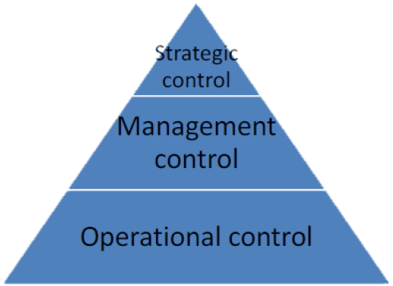 Anthony’s pyramid is a hierarchical representation of the levels of the executive information system.

These levels are:

* **Strategic planning and control**: where overall business objectives are defined and their achievement is controlled, planning information is very aggregated
* **Management control** (or executive, or middle management): financial resource management, how budget is allocated in order to fulfill strategic objectives. Here cyclical activity, high level budgeting and reporting, primarily concerned with financial resources
* **Operational control**: operating activities and how to use the resources to realize them is defined here

At the top level, strategic plans are made, and there is a flow from top to bottom of those plans and objectives. On the contrary, control information is created at the bottom and aggregated to be consistent and compared with the plans.

So, going down from the top, information becomes less aggregated until it becomes more operational information and can be used by executors to execute tasks.

People tend to commit to plans that are feasible, easy to do, especially at operational level, because this way when they commit a plan, they know exactly what needs to be done.

Plans can be made using the ERP, but also using other tools, which is a possibility as long as the data are then reported in the ERP. The main purpose of ERP is coordination, not to build new models. But the models have to be stored in the ERP in order to be followed. The value proposition of the executive portfolio is to make sure that plans are communicated seamlessly to the executors, and data are made available back to managers in order to perform decision making activities and to control how the plans are going, if the decisions were correct or could be improved. So, on the operating side the aim is to have clear plans to execute, on the managerial side the objective is to support decisions and to assess the quality of those decisions.

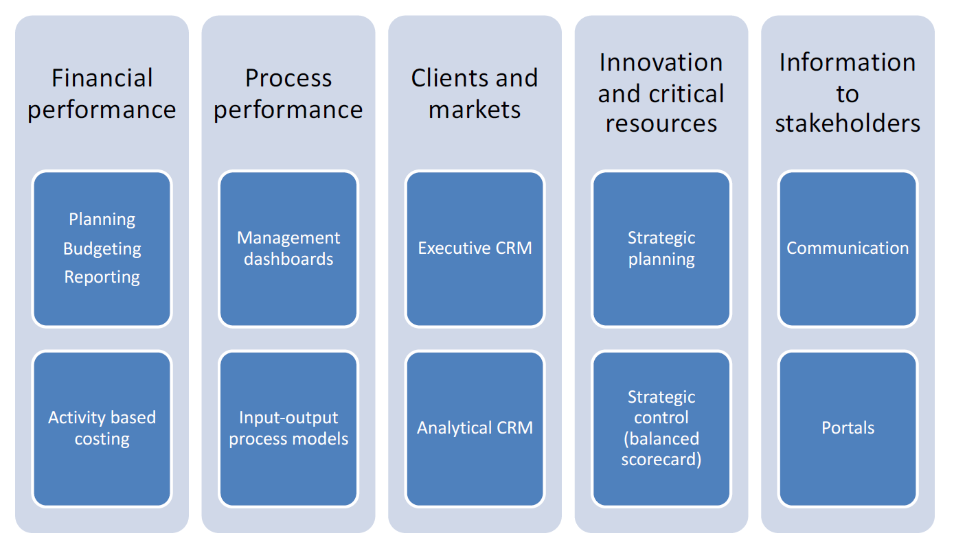

This chart is the functional map of executive information systems.

The 5 aspects are:

* Financial performance: planning, budgeting, reporting and execution of activity based costing
* Process performance: management dashboards, how the processes are proceeding compared to production plans
* Clients & Market: executive CRM and analytical CRM, to study the market and the customers
* Innovation and critical resources: strategic planning scenarios study and emulations
* Information to stakeholders: create the perception of the whole company for stakeholders using also formal communication

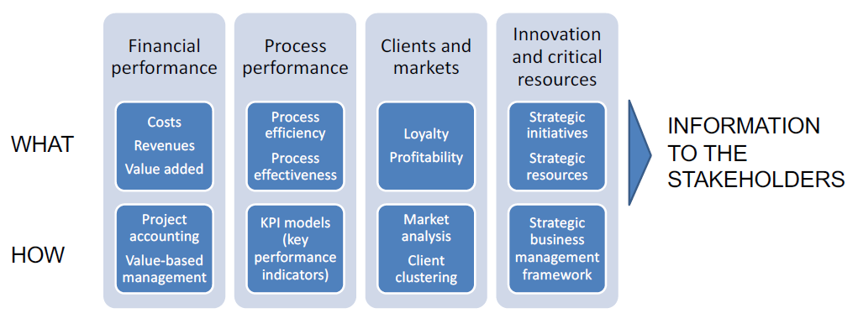

This chart contains the control models and variables to use in each aspect.

Some KPIs may be: ROI, total expense, return compared to taxes, average expenses by time, etc. The important thing with KPIs is to have a balanced set of them.

All these models need to be built on top of the data that the company has on the operational database. The data need to be detailed enough in order to support the model, or there would be no executive portfolio. So, companies can build an executive portfolio only if they have integrated horizontal and vertical operational portfolio.

Let’s analyze more in depth the different dimensions.

**FINANCIAL PERFORMANCE**

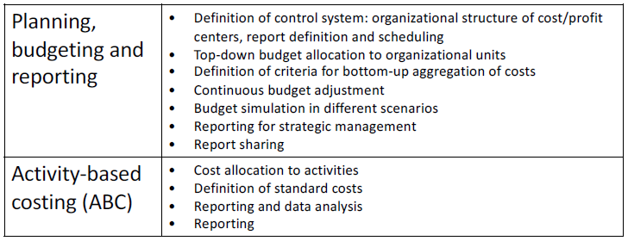

**PROCESS PERFORMANCE**

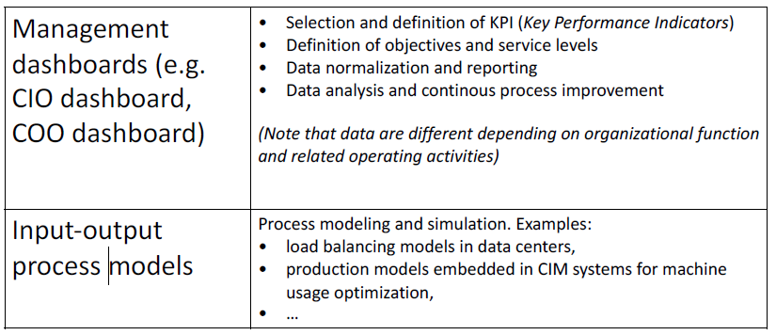

KPIs are to be seen as indicators of the performances of production processes, they are measurements of performance.

It is also important to remember that not all units generate revenues, they are not a "revenue center" but a "cost center".

**CLIENTS AND MARKETS**

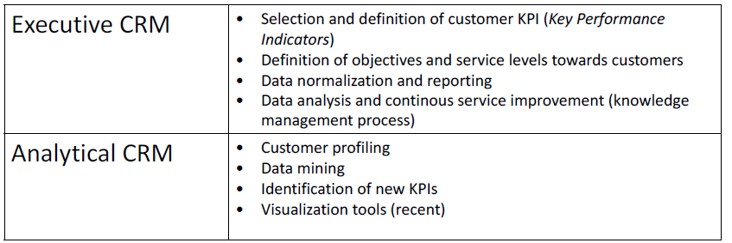

**INNOVATION AND CRITICAL RESOURCES**

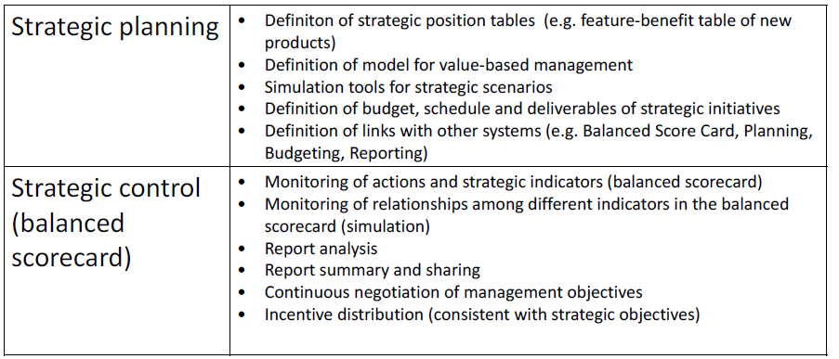

In order to do strategic planning and simulations, models of the entire company are needed.

The idea behind the balanced scorecard is that companies cannot pursue just one strategic indicator but they have to purse many and be good in all of them.

**INFORMATION TO STAKEHOLDERS**

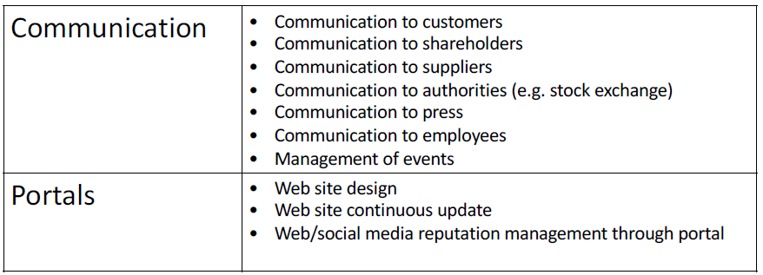

Communication takes place in different channels.

## Technology architecture of executive information systems

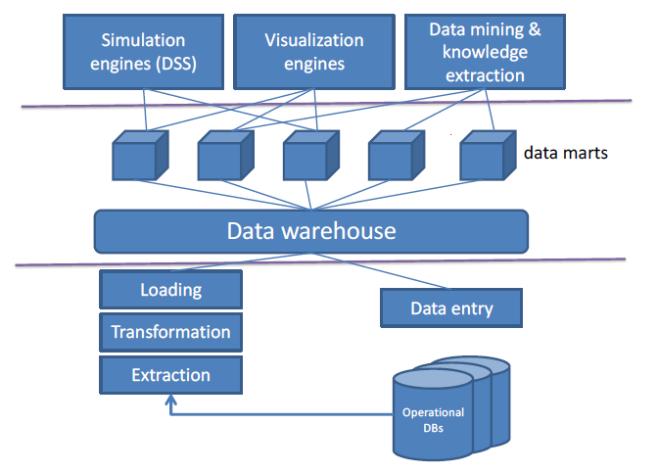

The operation data bases, containing transaction, planning and catalog information, are used to support operations but also to collect data. These data are useful for analytics, but it is not possible to run analytics directly on the operational data base: if analytics were run directly on operational DBs, the advantage would be to have real-time data, but data are still raw and not aggregated yet here and performances of the data bases and so of the operations would be affected. The reduction of speed could cause a reduction of capacity and cause congestions, so reducing performances is bad for operations and therefore analytics should be run in different places. A solution could be to duplicate the DB in order to perform extraction or analysis directly on it at any time, but this would involve a cost and the need to mirror the data of the first DB used in operations. Moreover, congestions in the first DB would lead to use the second, so duplication is generally avoided.

Raw data is extracted from the operational DBs, usually with batch procedures done when the operational DB is less used. **ETL** is the process used for extraction of data, and consists of three phases: extraction, transformation and loading of data. It keeps the separation between transaction and analytical data, as they are not compatible.

After the periodic execution of ETL, data go into the Data warehouse (or in data lakes in the modern case), where it is possible to play with data in a secure way. A **data warehouse** is a subject-oriented, integrated, time-variant,

nonvolatile collection of data that supports decision making process, where data are cataloged by dimensions following conceptual models and schemas (star, constellations, galaxy schemas). From here, data can be used to perform analytics and OLAP. A data warehouse stores pre-processed information that can be queried in real time.

For reasons of performance, efficiency, convenience, analytics often have their data marts with a subset of interest of the whole data on which they perform specific operations. **Data marts** are more manageable and small data sets that are targeted to specific applications. Data marts are a kind data warehouses.

|  |  |
| --- | --- |
| **OLAP** – On-Line Analytical Processing   * OLAP systems main function is decision support * Stored data are historical data, accuracy is maintained over time as data are summarized and consolidated * stored data are not guaranteed to be updated * OLAP systems main performance metric is query throughput * Example operations: Pivot, Roll-down, Roll-up, Dice, Slice | **OLTP** – On-Line Transaction Processing   * OLTP systems main function is to support day to day operation * Stored data comprises primitive, raw data * Stored data are guaranteed to be updated * OLTP systems main performance metric is transaction throughput. |

Aggregation of data is performed with some indicators, such as the KPIs – **Key Performance Indicators**. They are what is stored in the data warehouse: aggregate information providing a summary evaluation of a set of production activities or performance parameters. Executives express their information requirements by identifying key performance indicators to be calculated based on all operational data.

KPIs are always used together: only one KPI can distort the results of the analysis. Indicators have a value defined by different dimensions; in fact, in data warehouse every value has metadata describing dimensions of that data. Data should be aggregated in a way not to lose information as much as possible. Less granularity means less flexibility on data.

Basically, in data warehouse there are a bunch of tables that extract KPIs by interacting with the data, specifying ranges for different dimensions.

## Design steps of executive information systems

The steps to follow are:

1. Business requirements (key performance indicators): the definition of KPIs to be stored into the data warehouse
2. Information sources: once the KPIs are defined, it is needed to choose the sources to be used
3. Information transformation: when the tables of which database to get are known, data are transferred and transformed. Then the information transformed and aggregated is stored in the data warehouse.
4. Information storage: a schema for the information to be stored must be defined, and two tables are needed:
   * Table of facts: the aggregate transactions as KPIs
   * Table of keys: specify the dimensions of KPIs
5. Processing level: Presentation and reporting, Decision support engines, Visualization engines, Knowledge extraction engines

Typically, the information source is constituted by the operational DBs as the main source of information. They include: ERP operational data, CRM data, operational information from custom applications, from legacy applications, information from the administrative portfolio.

ETL comprehends the following steps:

1. Selection of data source
2. Data quality control and data cleaning: data cleaning is needed when it comes to analytics, maybe a product doesn't have enough info, or you can have issues with the software, or some data may be recognized as wrong
3. Data integration: different data bases can represent the same information in different way, and data coming from different sources have to be integrated with the same structure
4. Data aggregation

ETL is the only procedure that can be modify the data in the data warehouse, the executive portfolio can read it but not modify it.

Having an ETL procedure implies also convincing the rest of the organization that the procedure is correct and allows to embed in the procedure also the observations that come from different managers.

Load of information is periodical (it can be done for example every night). Data are loaded in a data warehouse and subsequently copied in a smaller databases called data marts to improve time performance. Data warehouses and data marts may have different schemas and involve an additional transformation step.

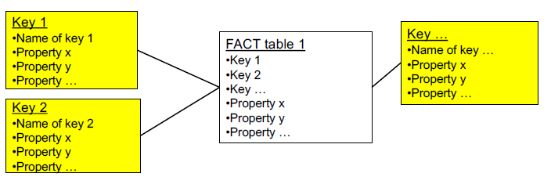

Fact tables store the value of indicators.

Keys represent the dimensions that describe facts.

The properties of keys are described in key tables.

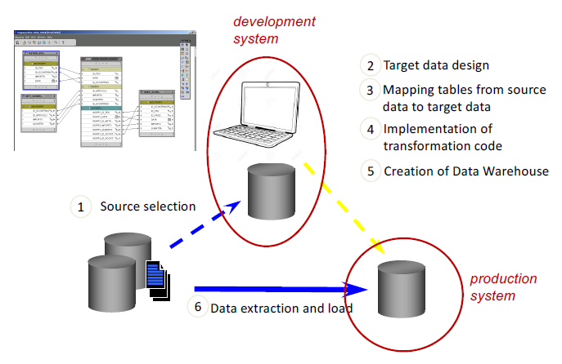

When doing the design of a data warehouse, computers and instances of the data

warehouse that are used for development are designed. Then, after there is the stable release, that is meant to be used by users the procedure has to be deployed in production and that makes the data available to the users in data warehouse.

The processing level includes: interactive visualization engines, mining & knowledge extraction tools, simulation engines, reporting.

## CSF method

A **CSF** – **Critical Success Factor** is a business decision variable critical for the success of the whole company. CSFs are abstract concepts, complex constructs which correspond to (but are not constituted by) multiple KPIs.

They are a representation for managers of what they want to keep under control in order for them to make the company successful. A CSF is a business decision variable critical for the company success.

The CSF method is a requirements analysis and specification method for executive information systems. The CSF method supports the elicitation of information requirements of top managers, as a fundamental input to the requirement analysis of the Executive Information System.

It consists of the following steps:

1. Predefinition: desk analysis, when the company is studied. The purpose of the preparation phase is to prepare for the interview phase, given that the interviewees are executives with a very short time and span of attention.
2. Interview: with top managers, aimed at identifying CSFs
3. Robustness analysis: aimed at selecting KPIs from the CSFs defined
4. Refinement and documentation: presentation to customer, possible modifications, specification (written, but informal)

CSFs are an abstract concept and must be associated to the related KPIs and can correspond to a variety of them. But CSFs are not a set of KPIs, but a distinct concept.

During the robustness analysis, there are different criteria to evaluate/select KPIs:

* Cost of information (e.g. customer satisfaction is costly).
* Significance, that is contribution to understand corresponding CSF. Answer to the question: how significant is the KPI considered for the desired CSF?
* Frequency, if information is seldom updated, KPI should be eliminated. Answer the question: how often it is needed to measure the KPI?
* Structuredness, quantitative is preferred against qualitative, as a number is objective and is best suited for analysis.

# 5. ERP Architecture

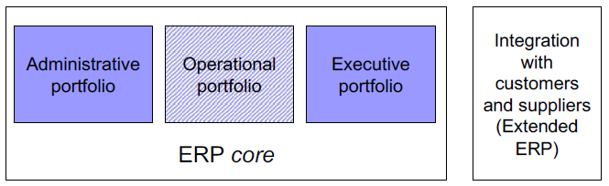

ERP stands for **Enterprise Resource Planning**, and this refers to all kinds of resources and assets a company has. The objective is to be able to manage all company’s resources from the same place, planning and controlling based on everything.

There is a distinction between:

* **Core ERP**: modules supporting internal processes
* **Extended ERP**: modules supporting the interaction with external parties, such as customers and suppliers

Depending on the business, a company may or may not want to have a flow of information with external parties or with a competitor.

Banks integrate with some of the services, while prefer to keep some things separated from their clients' ERPs.

Not all the functions are always available in the ERP of a provider: sometimes to remain more competitive it is easier to make life of the customer harder and make him do something the company could provide with a service but decides to not provide.

Core ERP modules include:

* Administrative portfolio
* Operational portfolio
* Executive portfolio

Extended ERP modules include:

* CRM, Customer Relationship Management
* PLM, Product Lifecycle Management)
* SCM, Supply Chain Management)
* E-Procurement and Market Place
* …

The functionalities of the extended ERP have in common to not be focused on the company only, but also on the interaction of the company with external parties.

When choosing an ERP, a choice has to be made: either choose an ERP and then adapt the company’s processes to the ERP, or the company selects an ERP that has the best possible combination of features related to their process and makes a compromise. When selecting an ERP, it is usually best to choose one to require minimal change: people may be change resistant and may avoid using it, going back to processes that are not automated.

In the ERPs’ landscape, there are more or less vertical solutions, solutions that fit more or less strictly for a particular industry. In fact, ERP providers usually start their business as specialized for a specific industry, and then expand to others the starting product (of course their ERP will always be best suited for the starting industry). Therefore, when choosing, it is necessary to ask: what industry is the strong point of this ERP? A client will make a market analysis, talk to more than one player, evaluate the offers and make a decision (this is a transaction).

Usually, it is not convenient to spend time in personalization of a package, better buy one already suited for the client's need and only do parametrization. In fact, the provider usually makes a business analysis of the customer company and then proceeds to the parametrization of the ERP.

Sometimes a hybrid strategy is taken when choosing an ERP: part of the package is bought and the remaining part is developed ad hoc. This has the objective of creating a competitive advantage on other companies which all use the same package. Organizations want flexibility from ERPs, but it is more convenient for providers to standardize their solutions as much as possible.

An example of provider is SAP: it’s an ERP that is not good for flexibility in small companies that cannot do mass productions and standardization, but good for big companies.

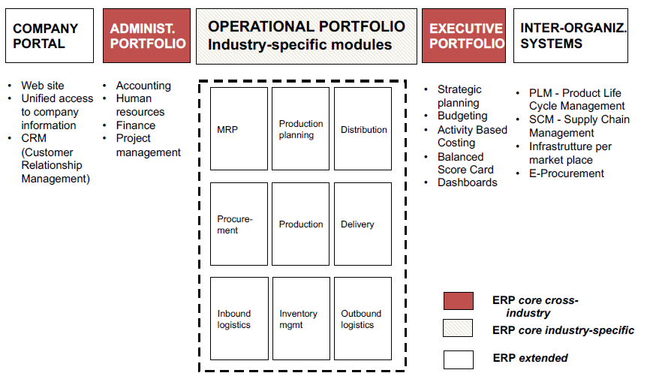

In the image, it is possible to see the functional architecture of ERP systems.

ERP have a modular structure, every box represents a module. Many of these modules are inter-functional.

When prone to add a new module, this overall map and the overall set of functionalities are to be taken into account. The question to pone is if there is a way to get somebody else in other functionalities involved to make a functionality work better and provide more benefits.

The ERP core is composed of industry-specific functions, typically most of the operational portfolio, and cross-industry functions, typically the administrative and executive portfolio.

## The ERP paradigm

The ERP paradigm is still based on the hierarchical model. It’s not focused on the individuals but it’s still focused on the processes. There are three pillars on which the ERP paradigm stands:

1. **Information integration**: all the information is stored in just one database and all the functionalities needed are based on it.
2. **Extension and modularity**: the ERP is composed of units and units can be added when needed so everything can be on the ERP. Each portfolio spaces a lot in terms of modules, for example administrative has a module also for human resources.
3. **Process prescriptiveness**: ERP embeds the process logic of the company. The software must follow the company process logic, or the company processes are to be adapted to the software.

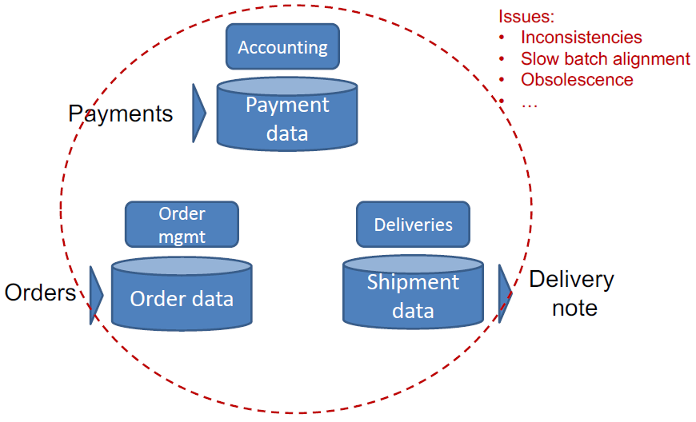

Before adopting an ERP, companies had a set of different and detached systems, each of them with their functionalities and their own data base. This approach had many problems, starting from inconsistencies of data, and the need to transfer the data every time where needed and when needed, obsolescence of data. An ERP implements an inter-functional mentality to solve these problems.

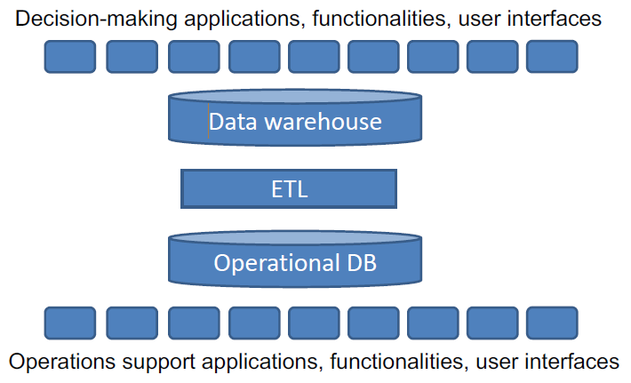In the ERP vision, there is just one operational data base, from where data are extracted in an effective way to be used by managers.

There is:

* Horizontal consistency: information sharing among functions
* Vertical data consistency: from operations to executive dashboards integrated in the ERP
* Conceptual consistency: one, common, integrated data and process model

This is still based on hierarchical view; there are also new paradigms, for example the one called holacracy.

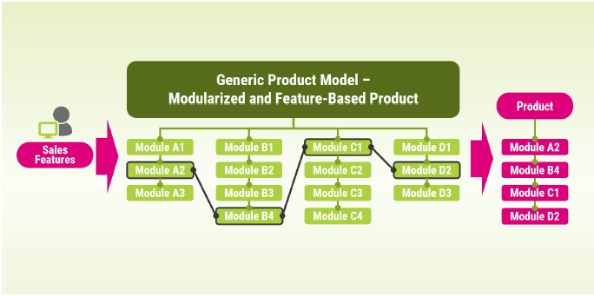

The modularity and the possibility of extension of ERP systems allows them to be potentially functionally complete. If something is missing, it can be added, and if something isn’t working how it is supposed or could work better, it is substituted.

Modules can be chosen with two different approaches:

* One Stop Shopping: from one supplier
* Best of the Breed: from multiple suppliers, instead of purchasing all the modules from a supplier, you can buy some modules from others. This option can be choosing when a supplier doesn’t have the modules needed or if a competitor has better ones for certain functions.

Usually companies go for One Stop Shopping, and use Best of the Breed only when they acquire a company which was using a different supplier.

Example: List of Modules (SAP)

* SD Sales and Distribution (active cycle)
* MM Materials Management
* PP Production Planning
* QM Quality Management
* PM Plant Management (maintenance)
* HR Human Resource
* FI Finance
* CO Controlling
* AM Asset Management
* PS Project (project management)
* WF Workflow
* IS Information System (statistics)

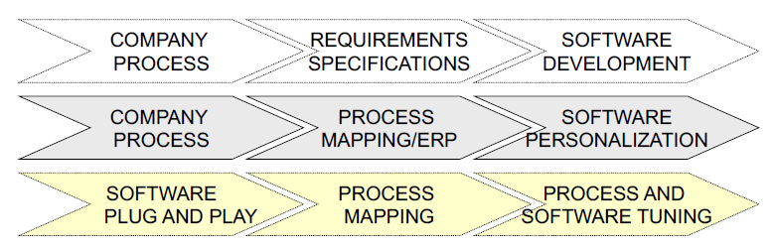

The third principle is process prescriptiveness: ERP packages embed a process logic.

Custom applications are developed ad hoc based on process requirements. But if ERPs bring in a process, organizations may have to change and conform to the logic embedded in the ERP.

There are advantages in prescriptiveness (speed and costs) and disadvantages (diversification/competitiveness).

Usually prescriptiveness is sold as a plus, but not always it is, especially if it pushes the company to whole restructuration of the processes to follow the ones of another company in the same sector.

*Observations*:

* No single ERP provider can offer all functionalities for all industries
* There exist niche players focused on industry-specific functionalities
* There’s room for system integration to integrate software from different suppliers (or with legacy systems), and companies often have developer do the system integration
* Small and medium size companies typically adopt:
  + Simplified ERP packages (**ERP light**): they do not provide the full set of functionalities and could be adopted by new companies that have just started their business and still do not need them.
  + Software as a service (SaaS) / Cloud-based solutions: they have many advantages, including that there is no need to have an infrastructure in-house. The company pays for the service.

There are also some alternatives to ERPs: SMEs, light ERPs “plug and play” with no BPR, simple administrative functionalities, simple analytics, limited scalability. When the company grows, the SME needs to be replaced by a classic ERP.

ERPs complete integration of operational and executive with the administrative portfolio: this enables a real-time reconciliation of budgets, resource consumption, progress of operations and cash flows. A fundamental concept of this integration is **Activity-based costing** (ABC), a module of ERPs integrating administrative and operational information on costs.

In ABC, operations are associated with costs, so there is an internal pricing systems making associations for operations. Thanks to this system, progress can be assessed from both a project management (time, quality) and financial (cost) perspective. As a result, progress can be reconciled with administrative cash flows.

This also solves the problem caused by the fact that some data, mostly economic ones, are usually gained months later their productions. So financial projections are needed and ABC solves this problem.

ABC allows to reconcile the actual expenses and cash flows with the planned expenses in real time, so the managers know exactly the progress of operations not only from the point of view of activities accomplished and time, but also from the financial perspective. That’s the main goal of ABC, to be able to assess the costs of the activities in a way that is as close to the cash flows as possible.

# 6. CRM

A **CRM** - **Customer Relationship Management** is a set of functionalities to support front end activities with an approach called multi-channel integration: serve many customers in many channels in a unified and integrated way.

A first objective is to improve B2B, B2C communication, synchronous or asynchronous, on different channels.

Costumers should have a consistent interaction with the company and should be able to choose the channel that they prefer or works better for them.

Different channels have different costs and degree of automation, but having more channels has advantages, for example availability. Every channel is a window on the company services, and can be used for comparison with other competitor’s companies.

Multi- channel integration ensures cross-channel service consistency. The service should be the same, independently of the channel on which it is provided, so to avoid customer dissatisfaction. Editors create information for channels, but different groups create info for different channels. They need to access a formalized set of data in order to deliver the same information to costumers.

Another important objective is value extraction from customer data with analytic CRM.

Then, customer understanding and monitoring with executive functionalities is possible.

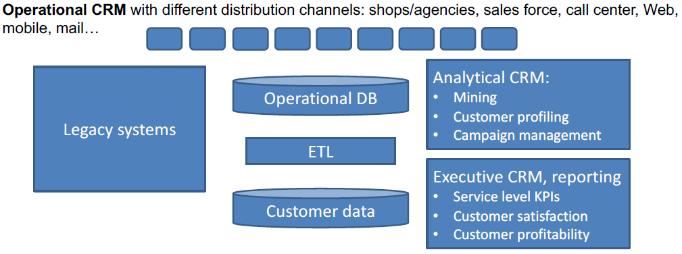

There is a distinction between front-end and back-end CRM:

* Front end applications/modules: composed by different interfaces (web, agencies, call center, sales force). Also has different types of users: employees, customers, visitors of the web site. They all take data from the customer DB, that is a unique DB made of data, integrated from different sources, and integrated with the operational DB.
* Back end applications/modules: functionalities used only by employees of the company, like campaign management, CRM analytics, executive CRM.

## Analytical CRM

It’s the part of the CRM where raw customer data, describing the interaction the company has with customers, is taken as input in order to be analyzed to understand customer’s behavior and needs. The results of these analysis are used also to improve the so-called digital experience of customers. In order to do so, new customer centric KPIs are introduced.

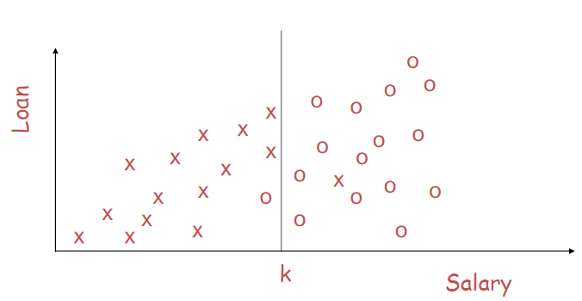A first module is the one concerning **mining**. Mining refers to data analysis with the goal of discovering insights that are relevant for business management. Mining can be performed with any technique: descriptive statistics (e.g. mean values), data visualization techniques (e.g. plotting data on a bi-dimensional chart), statistical correlations (e.g. correlating IT investments with sales). More recently, also with machine learning techniques.

Several companies have huge operational databases embedding new knowledge, and from them is possible to use data mining to extract patterns. Patters should be explained by summarizing findings in an intuitive way.

One of the techniques of data mining is clustering, with which customers with similar behavior are grouped. It is not a top-down approach in which segments are defined and then customers are assigned to them, but the opposite: a bottom-up approach in which customers are observed and from those observations clusters are created.

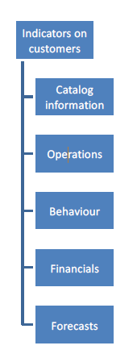The main idea behind mining is that looking at data it is possible to know something that wasn’t known before. As side effect, new KPIs are created. These KPIs are computed periodically and automatically.

Another module is **customer profiling**. The objective is to group clients in segments: people with similar habits in terms of purchases behavior (or behavior in general), so to discover patterns and assign patterns to type of clients. Customers who can be traced (with a loyalty card) can be segmented according to different dimensions, such as loyalty, price sensitivity, lifestyle, and so on.

Customer segmentation represents the basis for targeting promotions and creates a simpler scenario for decision makers to think and plan on.

There is a module dedicated to **campaign management**: a set of functionalities that support marketing campaigns. With it, it is possible to run and manage advertising campaigns simultaneously and consistently across different channels with high precision planning. KPIs are used for the definition of strategies, so campaigns are often targeted to segments of customers, and then the execution of the campaigns in usually automated.

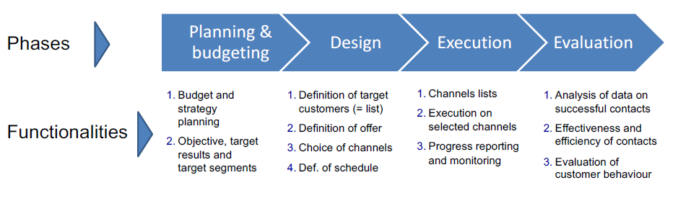

The objective can be to gain more costumers, for this purpose companies often buy data from external providers like Facebook or Google. With campaigns, managers aim to have higher revenues, and tend to spend a lot of money in marketing, as the more it is spent, the more a company can sell. But still marketing is expensive, so it is convenient to plan it based on data.

## Executive CRM

It is focused on data about customers, and it presents them in an aggregate format, summarizing info through KPIs to the end users, who are the marketing executives. Users need to monitor what customer do in a deep way, also because they need to assess the efficiency and effectiveness of different channels. The main KPIs are about customers’ segments, products, channels, and they are seen with a marketing perspective.

The main objective is innovation, to discover something about the customers’ behavior that will trigger new ideas in order to increase the company’s revenue.

The main module is **reporting** module. Reports show customer and product segments vs. KPIs. Data are extracted from the customer data warehouse (or from marts) and shown with the reporting functionalities of the CRM software.

## Operational CRM

A historical module of operational CRM is **Sales Force Automation (SFA)** with the goal to provide CRM front-end functionalities to the sales force in both B2C and B2B. Salesmen use this module to have updated information about the customer or the business they are going to interact with. Typically, SFA acts to support pre-sales activities, activities that are performed before the first transaction with the customer in order to convince him. The main functionalities are: customer DB access, agenda, pricing, offers.

Advantages for companies:

* Management perspective: governance of the sales force.
* Sales force perspective: stronger sales capabilities.

Operating objectives:

* Reduce the costs of customer acquisition.
* Increase customer retention.
* Reduce bureaucracy for customers and increase responsiveness during the sales process.
* 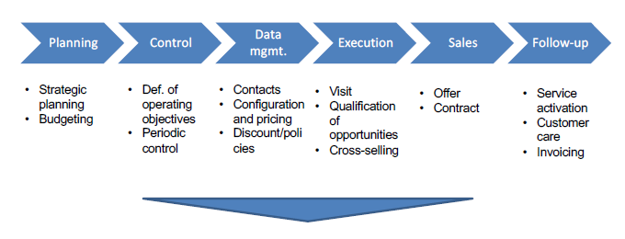Increase the effectiveness of the sales force.

About the **sales process on physical channels**, CRM provides the data that allow the definition of individual incentive

Systems. The sales force must have access to all information on customers, including invoicing.

Here is a list of the main performance indicators (KPIs) for physical channels:

* Effectiveness
  + Overall effectiveness= Contracts/Opportunities
  + Effectiveness of contacts = Contacts /Contracts
  + Investment in contacts= Contacts/Customers
* Efficiency
  + Productivity= Sales (in €)/ number of sales people
  + Unit costs= Cost of sales force (in €) / Contracts (number)
* Service level
  + Customer satisfaction = Value/Price.
  + Churn = Lost clients (number or sales in € or life-time value) / Total number of clients (number or sales in € or life-time value). This indicator is important when making an investment in order to gain more clients so to evaluate how not to lose old clients.
  + Retention = Loyal clients (number or sales in € or life-time value) /Total number of clients (number or sales in € or life-time value)

The physical channel is expensive, it is suitable for «rich» products, especially B2B.

With these approaches, the sales force tends to become the «owner» of data on customers.

## Call centers

The **call center** is a collection of people equipped with the phone, they receive inbound calls and make outbound calls. Having a call center is less expensive and more effective instead of letting people call directly a shop.

Call centers integrate telephone and computer technologies.

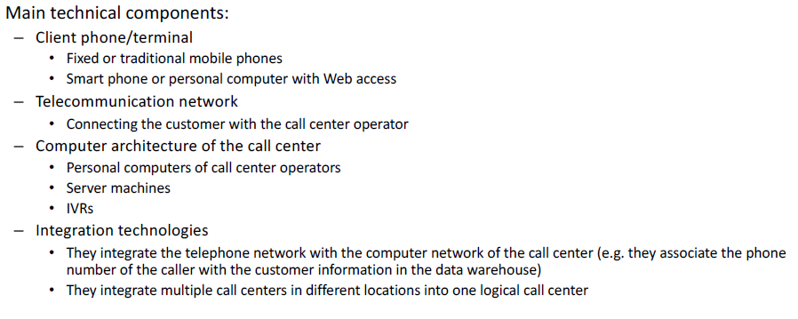

The performance of the call center has to be monitored. The cost of the call center is a function of:

* the number of calls in the time unit.
* the target level of service (waiting time and effectiveness in problem solving).

The level of service is specified in a document called SLA (Service Level Agreement).

Typical performance indicators are *First call resolution*(effectiveness), *Percentage of calls with waiting time lower than x* (e.g. 15 seconds), *Average call time* (efficiency).

In call centers, inbound calls occur in an asynchronous way, when the customer has a problem, so there are usually pics at certain times of the day. The trend of calls should be analyzed by the company, in order to correctly size the call center, and to make sure operators are always doing something when not answering to calls (for example they can do outbound calls). The CRM is fully integrated with these dynamics.

There are some indicators used the CRM:

* First call resolution of issues: percentage of customers that solve their problem with only one call. It is desirable that the customers do not need to call back. The CRM automates the calculation of this indicator for each operator in order to provide an indication of his effectiveness.
* Call backs: calls through which operators assess the satisfaction of the customer asking him some questions about the service.
* Average call time: for each operator, we should know also his efficiency.

Call center sizing: all indicators collected about the call center are used to size the call center in order to have the smallest number of people and simultaneously the smallest waiting time for the customer to get in touch with an operator, with the objective of determining the ideal number of operators and schedule of activities based on volumes of activity and SLAs. Schedules are constantly revised (in real time and automatically) to optimize performance. Each telephone operator represents a resource and is allocated on demand.

Usually, medium-term planning drives the sizing of plants and staff, while short-term planning drives the schedule of

outbound activities.

There are 4 steps, representing the kind of technology architecture of call centers, that can be followed:

1. **Basic architecture**: represents the least mature (simplest) type of call center with the lowest level of service, where there are hardware components that can distribute calls to operators (PABX - Private Branch Exchange), but in this architecture the call center is not integrated with the information system of the company. There is no automation: operators have only paper materials and catalogues about product, or paper materials can be put on standalone pcs not connected with the phone or whit the information system.
2. **Integrated architecture**: It integrates the call center with the information system through the CTI (Computer Telephony Integration) server. The caller is identified automatically and is associated with key information that is shown on the screen of the call center operator in real time. Pcs can be connected to the company information system. Operators share the same information, customer databases and information are integrated. Usually, the call center is organized in levels and operators are responsible to answer only to questions about a certain topic: according to the issue a customer has, he is redirected to a certain level of the call center.
3. **Full automation**: Simple (but very effective) automated systems are integrated into the call center technology and processes. These systems are:
   1. Interactive Voice Response (IVR): It responds to input from the customer (e.g. through keypad)
   2. Automatic Speech Recognition (ASR): It recognizes parts of speech. It proposes possible answers to the customers, iteratively.
4. **Integrated contact center**: It integrates the telephone channel with other channels, typically the Web, so customers can get information from the call center consistent with the other channels. Multiple channels are used simultaneously by the operators, who provide a more personalized service (e.g. Web chat, screen sharing). The same set of operators answers inbound requests from all channels and is in charge for outbound communication. It represents a costly architecture, but it reduces the operating costs of the call center.

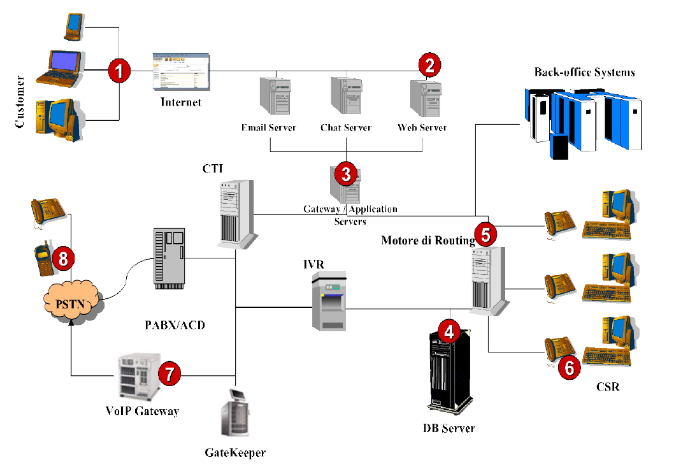

# 7. Business Intelligence

SDG is a company working in the field of business intelligence. It is a global management consulting firm, having a leading vision in the practices of:

* Business analytics
* Corporate performance Management
* Data-driven Services

The most important thing for a company working in business intelligence is the knowledge about business processes, as such a company stands in between the IT department and the business functions.

Business intelligence is something cross-industry, so not specialized in a specific industry like Fashion & Retail or Pharma & Healthcare, and works with different technologies.

**Business intelligence** (BI) is a set of methodologies, processes, architectures, and technologies that transform raw data into meaningful and useful information.

In order to run analytics, data has first to be transformed and integrated so to combine different information in the right format.

The flow of a business intelligence project, so the design process of a business intelligence system, is as follows:

1. Data identified and structured: what data is needed as input and its structuration
2. Expected output definition: what kind of analytics to run on data
3. Database model and design: design the data model that allows the desired analytics
4. Dashboards and visual design: definition of the kind of reporting desired

Business intelligence has a double focus. It has technical focus because there are always big volumes of data, so technologies that allows to manage them are needed, and it’s important to have performance in analytics, so they need to be run fast. Then there is a business focus because the use of the tools and data is found in business objectives, as operating with data is oriented to reach the goals that the managers of the company want to obtain. The data model is always analytics-centric.  
When designing and making the setup of the model, the focus is on which questions are going to be answered by that model. It’s key to ask yourself new questions generated by the analysis of data applied to the business model: Why do you need reports and analytics? Which are the business goals to govern? Which are the key dimensions? What is a right roadmap?

In the image some questions of business users in different industries are shown:

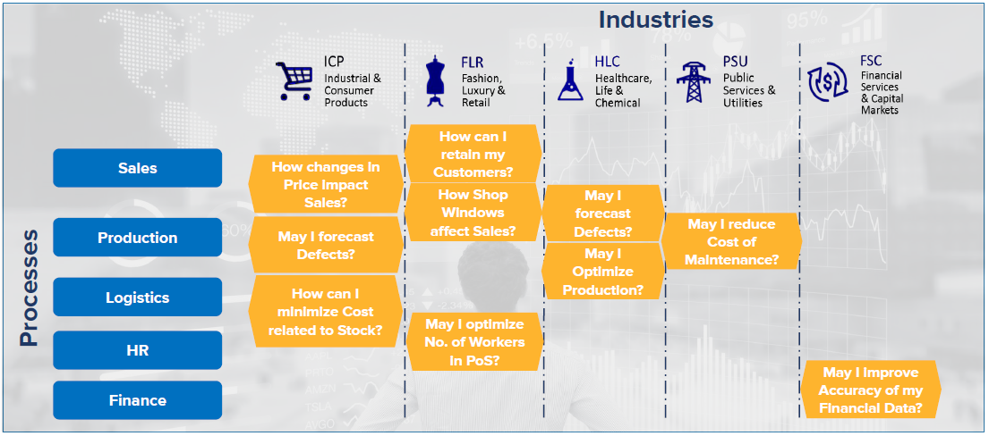

And in the next image there are some answers to those questions:

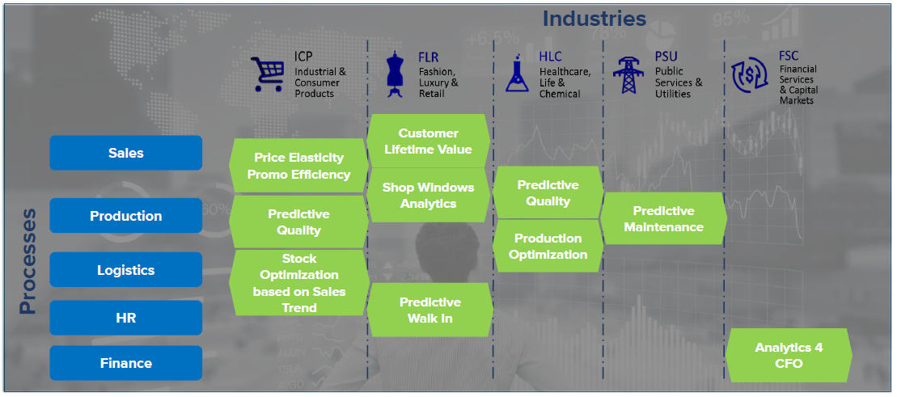

A Business intelligence mode is composed of:

* Source data: usually taken from the ERP of the company
* Data Model: where data from the source are imported, it is composed of two steps:
  1. Staging: where data are imported but no changes are made to them
  2. Information Model: where data are prepared to be utilized
* Reporting tools: on top of the data mode

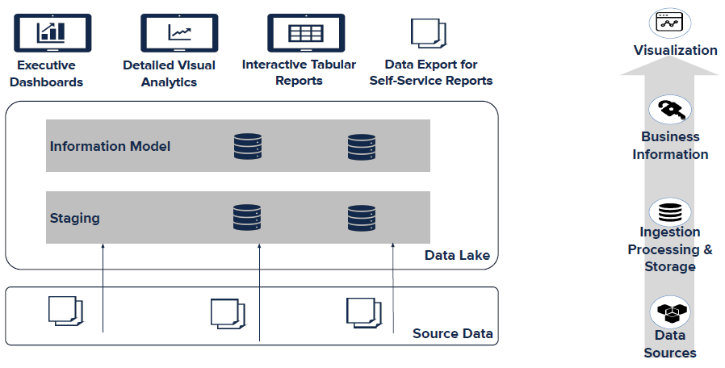

Some examples are: Financial Analytics, Sales Analytics, Ticket monitoring, Report for Production Director, Sell-out Data Analytics, Daily Dashboard.

**Sell-in**: how many units of a product is a manufacturer selling into the retailer

**Sell-out**: how many units of a product is selling out to the customer (from the retailer). So, data about the sales of products that are produced by a company but are not sold by it but by a different seller. Sell-out data are important for market share analytics. There are two types of sell-out:

* Off-trade: the off-trade market includes all retail outlets like hypermarkets, supermarkets, convenience stores, mini markets, kiosks, wines & spirits shops etc.
* On-trade: The on-trade market includes outlets like bars, restaurants, coffee shops, clubs, hotels etc.

In some cases, the user of business intelligence wants to analyze the data as he prefers, so without using default functions provided by reporting tools. Company users need to be able to perform their own analytics on the data model without constraints. This situation is called **self Service Analytics**. The dashboards are always the same of reporting tools, but the user can change the point of view of the analytics and drill-down other dimensions. So, the free analysis for users is provided by setting up of a dynamic structure environment to analyze business and financial facts at an atomic detail level and in a “ready to use” platform.

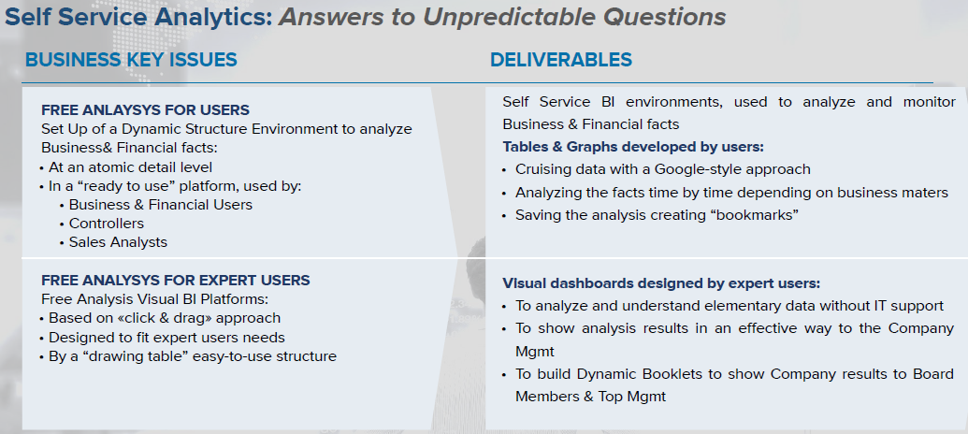

# 8. Project management in BI projects

## Business Intelligence projects structure

A **project** is a piece of planned work or an activity that is finished over a period of time and intended to achieve a particular purpose. A project always involves a defined timeline and defined goals.

A business intelligence project is carried out by a project team, composed by both consultants and people of the company they are working for.

The people from the company working on the project are divided in:

* *Functional Team*: business key users, who define the requirements and the analytics they want to perform
* *Technical team*: IT users from the IT department, who are in charge of letting consultants interface with the technology the company already has

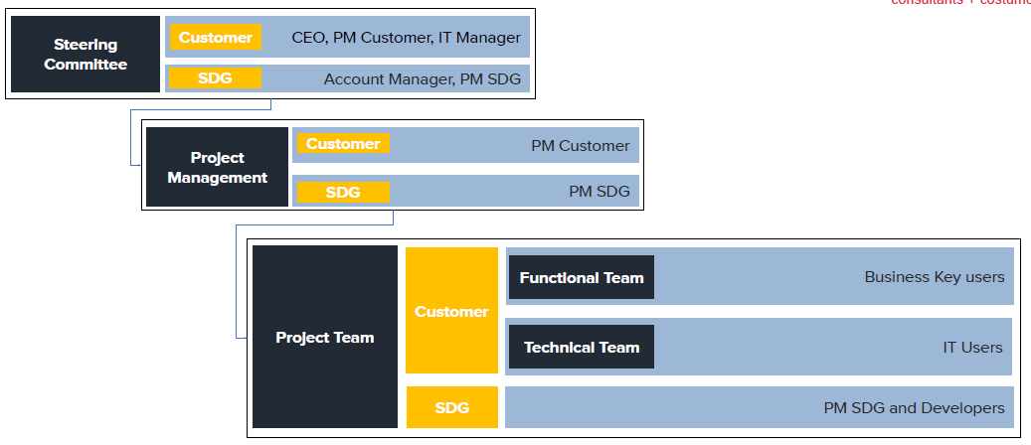There is always a project manager in both the customer’s side (from the company) and a manager for the consultants’ side.

The steering committee is not always present but always defined and is called for the main timelines and if there are issues with the project.

The project structure is composed as follows:

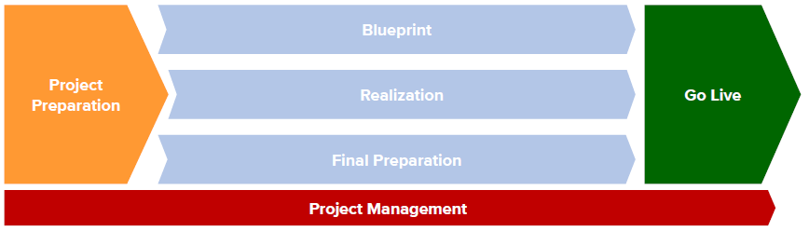

* Project Preparation: high level requirements are collected. A global implementation strategy is defined, together with staffing and resource planning.
* Blueprint: analysis is performed. Requirements are collected in onsite meetings with business users. Solution is defined and summarized in Business Blueprint document.
* Realization: solution defined in the previous step is implemented and tested by developers. Solution is released to be tested by users.
* Final Preparation: solution is tested by business users (UAT). Test cases previously identified are reproduced through a suitable dataset.
* Go Live: solution approved by users, if necessary integrated with changes required during UAT, is released to Production environment and populated with real data.
* Project Management: organization and planning of project activities. Monitoring, check of actual respondence to plans, relationship with client.

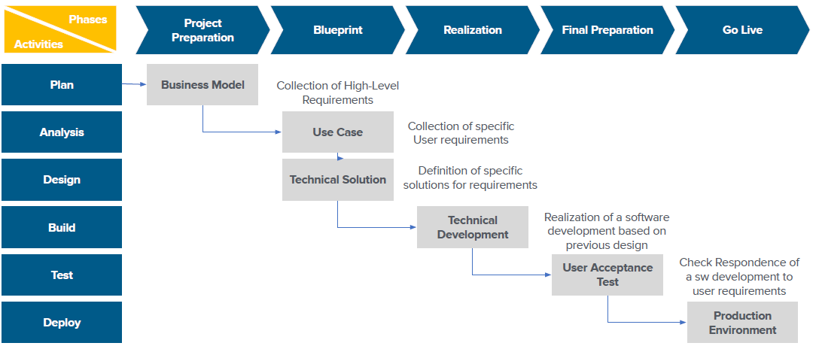

In the image above activities associated to each phase can be seen.

When collecting requirements, it is useful to keep in mind two things. The first thing is that often there are different end user, with different needs. It’s important to collect all the requirements, leading the analysis towards the final goal. The second is that there is always a trade-off between “having as much information as possible” and “having an easy-to-use application”.

During the design of the technical solution, based on the project goal (user requirements). It is produced a design document to delivered to the customer, and this document needs approval before proceeding with the project.

The central phase of a software implementation project is realization, but it is not the phase where the majority of time is spent, in fact it’s really usual to spend more time in other phases than in the realization one.

The realization always follows the following schema:

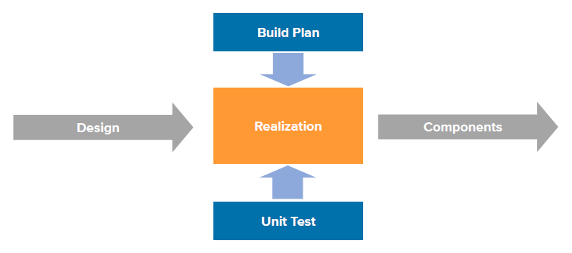

Particular importance during this phase is assumed by the concept of *unit test*. Single components of the software are tested singularly as soon as they are ready before being integrated with the others.

Most BI tools work with different environments. An environment is the place where there are the data model and the reporting. There are generally:

* development environment: where the development and unit testing happens
* quality environment: where the user acceptance test is made with a realistic set of data
* production environment: where there is the live usage, so where the users can see the dashboards, reports and data that are inside the model

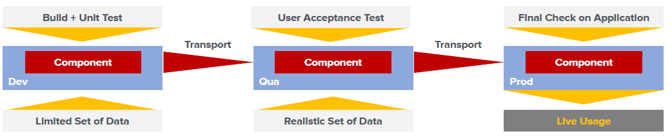

Three different environments are often needed, but sometimes the quality environment isn’t present.

**Packaged Software**: software not built from scratch, but with a preconfigured model where developer can work on (customization).

Customization takes place on applications deployed on a server (client – server configuration). Application Build is performed on a Development environment, that relies on a server different from the Production environment. To move developments from Dev to Qua and from Qua to Prod, transports need to be performed, but before them, developments need to be tested. Tests require a suitable set of data to give a reliable outcome on the software components, and every environment has its own kind of data.

After the development, in the quality environment, *user acceptance tests* can be performed. During this phase, users have to verify the quality of the solution developed in terms of correctness and compliance to their requirements. There might be rework during the UAT phase, due to misunderstanding between business users and developers. The requirement analysis and the Blueprint document have the goal of avoiding this cases. It is anyway important to make a distinction between the happiness of the user and how the solution I coherent with the requirements collected.

At the end, with the project going live, there are two important aspects that are: end user training and post go live support.

Along all the phases, testing is present. Testing is a process of checking the final product to ensure it meets requirements and expectations under operating conditions. Testing is done by executing system functions through a series of predefined use cases and evaluating compliance with expected results.

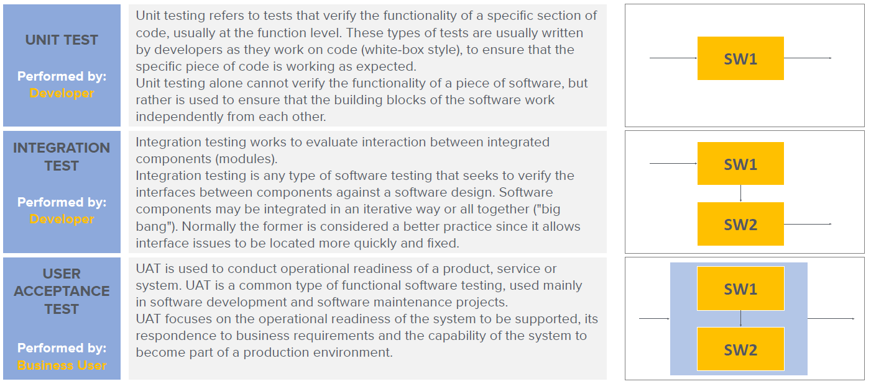Three main types of testing are relevant:

## Business Intelligence projects approach methodologies

There are two main project methodologies:

* **Waterfall** or **Linear**: Project is executed along well-defined stages aiming at completion with expected deliverables to stakeholders.
* **Agile**: Iterative development methodology that values and encourages communication and feedbacks, fast adjustment to changes and focuses on incremental working results along the way.

The waterfall model is the most classic model to design and develop pieces of software, all the other models are derived from waterfall. It is based on a clear definition of project phases and their sequence, in which each phase takes output of previous phase as input and generates an output used by subsequent phase. In case of issues in a test phase, process can come back to previous phases, so to the coding phase, and re-start the tests.

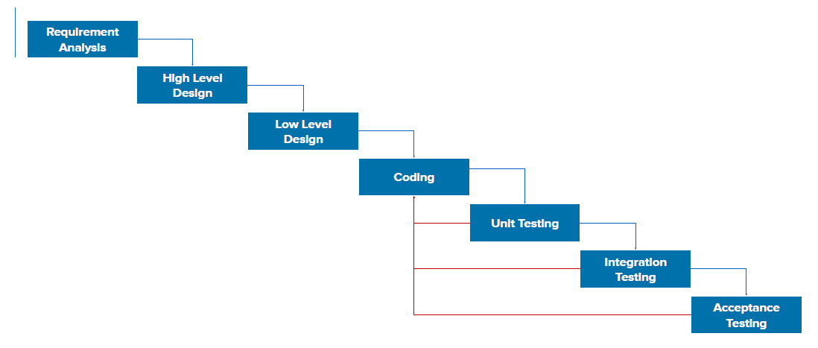

|  |  |
| --- | --- |
| Waterfall Model Benefits:   * Lowers defect resolution cost due to earlier detection * Includes validation and verification at each level for stage containment * Provides improved quality and reliability * Reduces the amount of rework * Increases testing efficiency with added focus on testing objectives * Ensures better scope definitions through requirements traceability * Improves risk management * Encourages focused efforts by determining the success criteria up front | Waterfall Model Limits:   * The Waterfall Model does not permit going back and forth between the development phases.   This may result in:   * Difficulty to implement changes when requirements change * Inability to revisit design upon discovery of problems during implementation * Need for constant testing * Difficulty in estimating time and cost for each phase. |

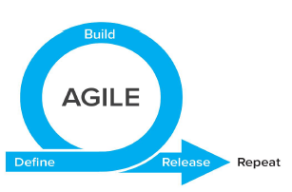

The agile methodology aims at overcoming the waterfall model limits. In this approach, in order to avoid bad surprises at the end and to stay open to changes, development becomes continuous.

Realization phase is divided in a series of a cycles with the scope of realizing a subset of technical components. Each cycle has a complete internal structure: realization, test and deploy.

The overall project management is aimed to ensure respondence of cycles to the general objective of the project.

In general, this approach is more expensive, because doing changes to a model is always costlier than following a pre-defined model.

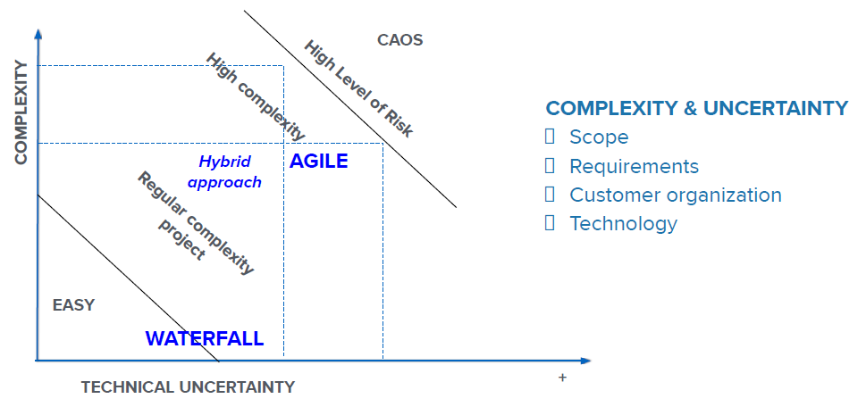

With high uncertainty, the agile approach might be better, because there are few definitive ideas at the beginning of the project. On the other hand, when complexity is high, it is better to think beforehand of a structured solution, that solves all the problems.

When there is few uncertainty and few complexity, both approaches are fine but waterfall is usually preferred.

# 9. Business intelligence with SAP

## ERP and Data warehouse

ERP, or **enterprise resource planning**, is a modular software system designed to integrate the main functional areas of an organization's business processes into a unified system. In an ERP, the company stores all kinds of data, and these data are integrated, along with the functionalities provided by the ERP.

An ERP system includes core software components, often called modules, that focus on essential business areas, such as finance and accounting, HR, production and materials management, customer relationship management (CRM) and supply chain management. Organizations choose which core modules to use based on which are most important to their particular business.

What primarily distinguishes ERP software from stand-alone targeted software is a common central database from which the various ERP software modules access information, some of which is shared with the other modules involved in a given business process. This means that companies using ERP are largely saved from having to make double entries to update information because the system shares the data, in turn enabling greater accuracy and collaboration between the organization's departments.

Usually, data are extracted from the ERP and put in a data warehouse. An **Enterprise Data Warehouse** is an integrated and centralized repository of historical, detailed data that supports multiple decision-making applications for multiple groups and it should be the single source of data for the enterprise.

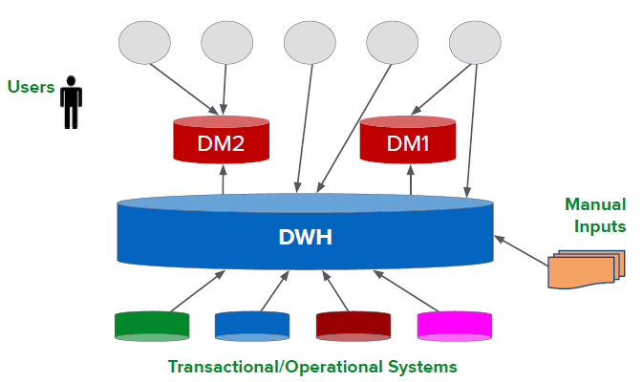The data warehouse must:

* make an organization’s information easily accessible
* present the organization’s information consistently
* be adaptive and resilient to change
* be a secure bastion that protects company information assets
* serve as the foundation for improved decision making

A **Data Mart** is a subject oriented archive that stores data and uses the retrieved set of information to assist and support the requirements involved within a particular business function or department within the enterprise. So, on DM there are different reports for different users, and DM are user oriented and contain subsets of data of interest of a type of user.

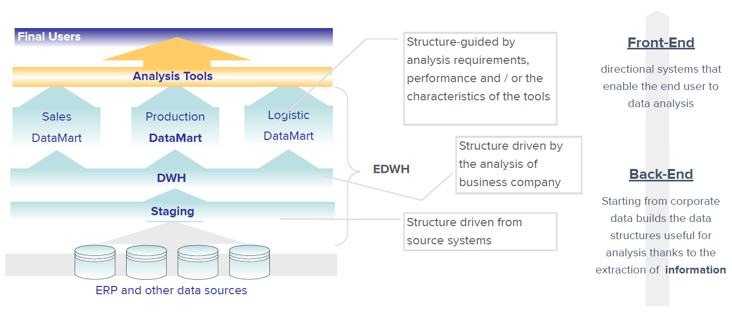

Depending on the technology, different sources are used to take fata from to be integrated in the data warehouse. The first layer of the data warehouse is the staging layer, where data is imported generally without any changes. The second layer is the data warehouse (DWH), where the data model is performed. While in the staging the structure of data is driven by the enterprise resource system, in the DWH layers the structure is different according to the output and the needs of the users of the data warehouse. If the model in the DHW is too huge, so difficult to play with, it is useful to build data marts containing only part of the whole DWH. This is useful mostly for a performance point of view. On top of the data marts, or directly on top of the data warehouse if there are no data marts, there are the analysis and the reporting tools. Here, with reporting tools, is where the front-end starts, while all the structure underneath is part of the back-end.

DWH and Business Intelligence environments are mainly based on data, so it’s mandatory to have the right approach and the right tools to manage data with stability, robustness and in a centralize manner.

**ETL** refers to a process in database usage (especially in data warehousing) and stands for:

* *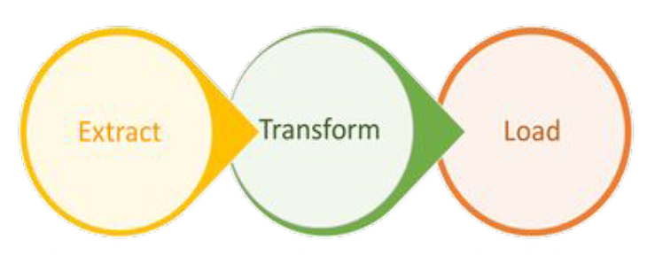(E)xtract*: data is extracted from homogeneous or heterogeneous data sources
* *(T)ransform*: data is transformed for storing in the proper format or structure for the purposes of querying and analysis
* *(L)oad*: data is loaded into the final target database, more specifically, a data warehouse

Not necessarily the ETL tool needs to be of the same technology of the ERP or of the DWH.

## SAP - Systems Applications and Products in Data Processing

SAP, which in English stands for Systems Applications and Products in Data Processing, is a German multinational

company with headquarters in the city of Walldorf in Baden-Wurttemberg. Founded in June of 1970, SAP is now considered the 4th largest software company per revenue in the world. SAP is famous mostly for the ERP part of its offer. Here is an overview of the main tools framework of SAP:

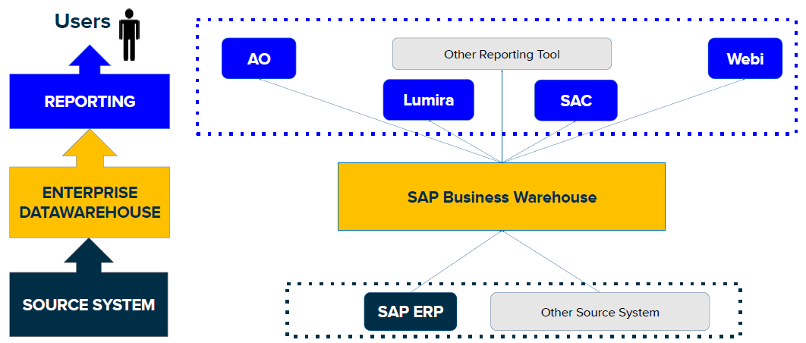

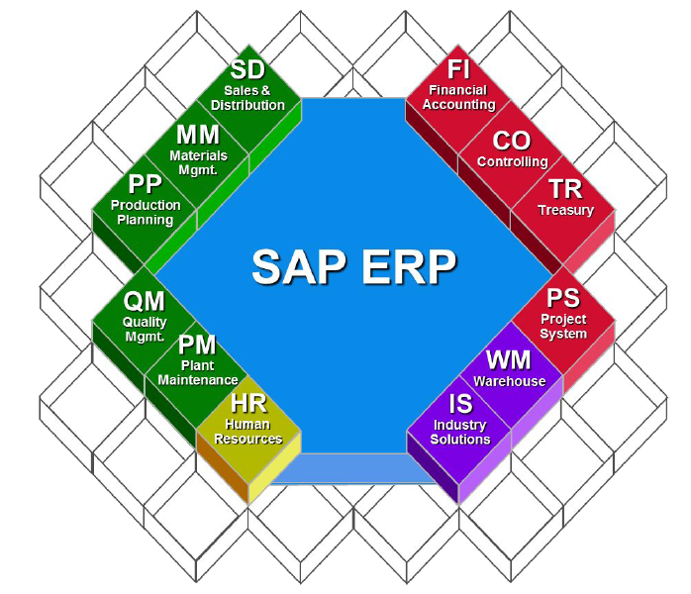**SAP ERP**

SAP ERP is an enterprise resource planning software developed by the German company SAP, which incorporates the key business functions of an organization, collecting and combining data from the separate modules to provide the company or organization with enterprise resource planning.

|  |  |
| --- | --- |
| SAP ERP benefits:   * Allows easier global integration (barriers of currency exchange rates, language, and culture can be bridged automatically) * Updates only need to be done once to be implemented company-wide * Provides real-time information, reducing the possibility of redundancy errors * May create a more efficient work environment for employees * Vendors have past knowledge and expertise on how to best build and implement a system * User interface is completely customizable allowing end users to dictate the operational structure of the product | SAP ERP constraints:   * Locked into relationship by contract and manageability with vendor: a contract can hold a company to the vendor until it expires and it can be unprofitable to switch vendors if switching costs are too high * Inflexibility: vendor packages may not fit a company's business model well and customization can be expensive * Return on Investment may take too long to be profitable |

Some of the main modules of SAP ERP are:

* SAP SD: SAP Sales and Distribution (SD) is an important module of SAP ERP consisting of business processes required in selling, shipping, billing of a product. Key sub-modules of SAP SD are Customer and Vendor Master Data, Sales, Delivery, Billing, Pricing, and Credit Management.
* SAP PP: SAP Production Planning (PP) is the process of aligning demand with manufacturing capacity to create production and procurement schedules for finished products and component materials. It tracks and makes a record of the manufacturing process flows and monitors goods movements from the conversion of raw material to semi-finished goods. A sub module may be quality check.
* SAP MM: Materials Management (MM) module manages materials required, processed and produced in enterprises. Some of the popular sub-components in SAP MM module are vendor master data, consumption based planning, purchasing, inventory management, invoice verification, material resource planning, and so on.
* SAP FI: SAP Financial Accounting (FI) records financial transactions of all movements of goods, services and all other business transactions between the company and its customers and vendors. SAP FI application represents from an accounting perspective a company general ledger (G/L).
* SAP CO: The Controlling (CO) module of SAP provides information to managers & decision makers to understand where the company's money is being spent. It not restricted by any legal requirements as in case of FI & is essentially an internal cost accounting tool.

In any module there are the main transactional data of that module and also the main master data useful for the operations.

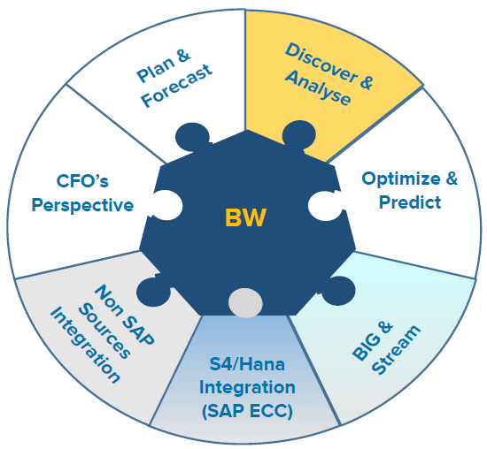**SAP BUSINESS WAREHOUSE**

SAP Business Warehouse (BW) is the tool, inside the SAP offering, thought for Business Intelligence initiatives. It is the main solution that SAP applied to implement the Data Warehouse.

The objective of this tool is to integrate big quantities of data maintaining good performances.

SAP BW is known as an open, standard tool which allows you to extract the data from different systems and then send it to the BI system. It also evaluates the data with different reporting tools and allows to distribute them to other systems.

It’s also open towards different external source systems, specifically with Big Data and Hadoop solutions, in addition to traditional SAP ERP systems or transactional systems in general.

The last version of BW is called SAP BW/4HANA, which is optimized to be used with SAP HANA data base technology. Usage of SAP BW version based on Hana allows to customize data flows either at BW application level or database level.

SAP HANA® is a platform that is composed of the database and of services and tools. It enables real-time business by converging transactions and analytics on one in-memory platform. It can run on premise or in the cloud, and aims to bring savings in data management and empower decision-makers with new insight and predictive power. The main characteristics of HANA are: in-memory processing, real-time insight from big data, data replication and virtualization, support for modern applications that use multi-model data, tools oriented to security and dependability.

Inside the environment, BW4Hana Objects are collected into InfoAreas and can be divided into:

* Persistent objects: include directly a physical table with typical data in the DB.
  + InfoObjects: used for master data (*CH*aracteristics) and measures (*K*ey *F*igures), have different dimensions of analysis inside multidimensional structures. Example: customer, product, quantity, amount.
  + advanced Data Store Object: used to integrate transactional data, in a flat table that can assume different functions. Example: invoices.
* Virtual objects: views on the data that are stored in other objects.
  + Composite provider: allows to join or union different data store objects, making them available for reporting and analysis.
  + Open ODS view: represents a view on only a specific source or object and adds analytic metadata to this source.

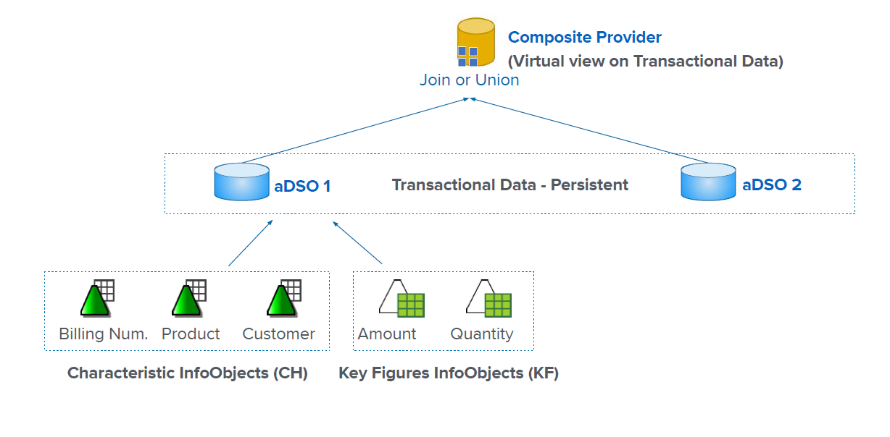

An aDSO is composed of InfoObjects, both CH and KF, and it’s where transactional data are stored.

Characteristic InfoObjects may have master data, where there are descriptions for the codes as well as attributes.

At the end, reporting tools are divided in more reporting-oriented tools, where focus is on numbers, and more data visualization-oriented tools, where focus is on finding out new relationships between information.

## Data extraction and integration

There are different methodologies that are possible to extract data from external sources and integrate data into BW. Depending on the kind of sources and destination, one methodology might be better than the other.

* **Data services**: more classical ETL tool, which allows to extract data from any source and upload them in any destination, so is a versatile and comprehensive data provisioning tool.
* **ODP**: standard extractors of SAP, with which is only possible to take data from SAP ERP and update them in SAP BW. The advantage of this solution is that it is the one where all characteristics of SAP systems are integrated.
* **SLT**: SAP Landscape Transformation is the real-time replication instrument of SAP. It can be used with every data base (not necessarily SAP) to upload to any compatible DB. The advantage of this solution is the real-time feature: every time there is, for example, a new invoice, it is immediately uploaded. The side effect of this approach is that it affects performances of operational DBs.
* **SDA**: Smart Data Access allows to open a connection to a very large number of sources (databases, web services). The replication of tables / views from source to the target database is not physical but virtual.
* 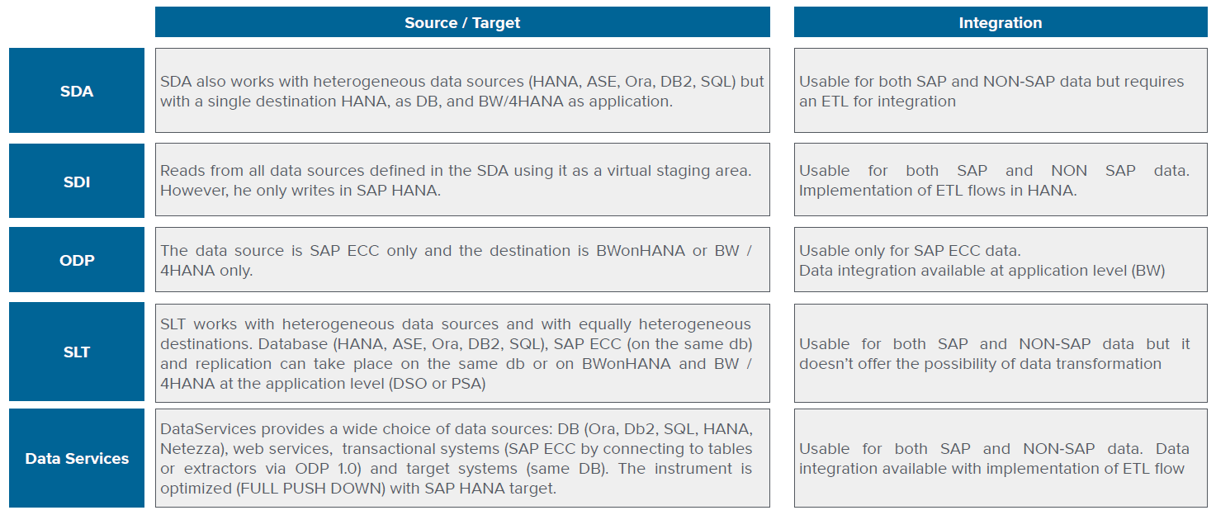**SDI**: Smart Data Integration is a data provisioning tool which is responsible for extracting information and uploading it to the latter. It is possible to schedule jobs or set real-time jobs (only if supported by the source).

Extraction from ERP System is the activity that allows to export Data from the ERP System, in order to import them in another environment. The structure used to extract data from ERP is called Extractor (or Datasource) and it’s a cross component between source and destination system.

The extraction of data from ERP systems can be performed by:

* Standard extractors: data-source to extract from standard sap tables such as material master data or sales document tables. They are based on a set of rules to store the data in data store objects.
* Custom extractors: it is possible to create a custom data-source on any table or view in the ERP System.

The extractors can also be classified in two kinds:

* *Application specific*: used for specific areas (ex: SD, sales)
* *Cross – application*: used, for example, to extract data from custom tables

The release management of BW and ERP are managed through three different environments:

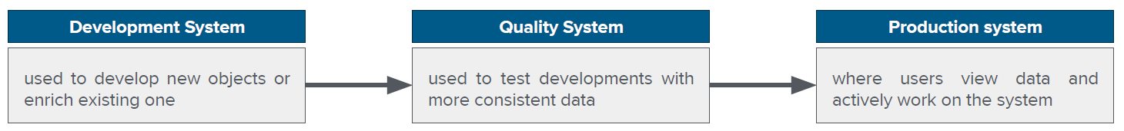

Generally, there is a connection one-to-one between the same environments of ERP and BW system, meaning for example that data imported to BW quality are extracted from ERP Quality system.

## User securities

Every time a reporting is created, not always the data required could be seen by everyone. The part in which who can see the data and how is defined is called **user securities** or **user profiling**.

Users in a BI system generally have different roles in terms of:

* What to do
  + developers: create the data model and reports
  + business users: view reports
* What to see
  + CFO: all reports
  + Sales users: only reports of sales area
* Which portion of data
  + group sales manager: sales data of all companies of the group
  + local sales manager: only sales data of his company

This is a common issue when different companies share a common system.

## Back-end vs Front-end

Generally speaking, it is possible to asses that front-end is where the reporting is, while back-end is where the data modeling happens. Usually, back-end is the bigger part of the two, but not the most important, as data to be useful need to be shown and analyzed in the right way. So, Data are only useful when available for analysis.

**Data visualization** is the technology enabling corporate users to «see» data, to support them to better understand the information and using them in a business objectives perspective.

In the back-end is defined the logic for data storage and management, rules for creating dimensions of analysis. The back-end handles business logic and data storage, it consists of servers, applications, and databases. In the back-end there is the data access layer.

The decision, for example, to create a dimension or perform an analysis in in the front-end, with the data visualization. Front-end web development is the practice of navigating data as well as converting them to graphical interface for user to view and interact with data. In the front-end, there is the data navigation and visualization.

## Data visualization

Reporting consists in accessing to data and reading it as it is, looking at tables. Data visualization is different from reporting.

In **data visualization**, information is presented to the user without needing him to check and find information. Data visualization makes it easy to recognize patterns and find exceptions while interpreting the data at a faster pace. It allows access to challenging data sets, it allows exploration, can be fun and provides useful information in an efficient way. It leads the user, creating a path for him to explore the data following a particular focus on them.

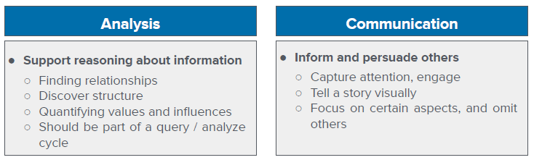

For every dashboard, it is important to know what is its purpose. The objective is not to show all the data in a certain field (like in reporting), but to show only inherent data. In this way, it is important also to know the target audience for the dashboard created.

## Predictive analytics

**Predictive analytics** are able to forecast customers demand helping the optimization of the production as well as the warehouse stock level of the company, allowing to make your decisions with data driven awareness.

Predictive and more generally speaking advanced analytics are rapidly becoming more and more easy to deploy and take advantage of. Nevertheless, in most cases it is necessary to invest in a whole new system dedicated to the only purpose of performing a statistical analysis. Traditionally, this predictive system is a R server that communicates with

the data warehouse.

Communication must take place both ways:

* row data must be feed into the predictive system, from the Data warehouse
* the predictive system needs to return the result of its advanced analysis to the data warehouse where data visualization applications are usually deployed

SAP has a tool for predictive analytics, that is SAP Predictive Analysis Library (PAL). These are a set of predictive and advanced analytics algorithm embedded in the SAP HANA database. The main advantage of PAL is that the advance analytics can take place in the data warehouse itself. This means no need for more maintenance on a new system and no ETL (Extract, Transform, Load) needed for communication between the data warehouse and the predictive system.

There are many categories of algorithms in the Predictive Analytics Library that allow many possible business usage scenarios. Some examples are:

* Time series: forecast of future sales values given a set of historical data;
* Clustering: grouping of a set of customers based on master data and buying behavior;
* Classification: forecast customer behavior based on master data;
* Regression: analyses the relationship between marketing campaigns and sales trends.
* Association
* Preprocessing
* Statistics
* Social Network Analysis
* Miscellaneous

Regarding the Time series algorithms, a time series is a sequence of observations taken sequentially in time. The purpose of time series analysis is generally twofold: to understand or model the stochastic mechanisms that gives rise to an observed series and to predict or forecast the future values of a series based on the history of that series.

**Time series analysis** comprises methods for analyzing time series data in order to extract meaningful statistics and other characteristics of the data.

**Time series forecasting** is the use of a model to predict future values based on previously observed values.

The **forecast detail** is the combination of dimensions that we decide to use for the forecast. In a time series forecast, it is the level of detail of the series both of the past data and the predicted ones.

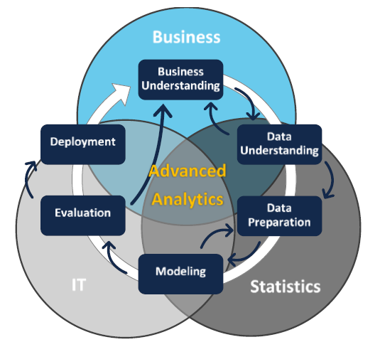Any Advanced Analytics project should be driven by Business, Statistics and IT. These three spheres provide Validity, Intuition and Automation and should always be considered together in all the phases of the project. The overlapping of these three worlds allows to develop an application that automates data collection, processing

and analysis and can provide Insights. Furthermore, the process is highly iterative: the lessons learned during a phase of the process can trigger new and more focused business questions; subsequent iteration benefits from the experiences of previous ones.